24/07/24
UI Module (Front End)
- HTML
- CSS
- JavaScript
- Bootstrap

Duration Course: 2Months
Class Timings : 9:15AM – 10:50AM (MON-SAT)
Telegram : codewithsatishgupta

2 Projects
-----------------------------------------------------------------------------------------------

Types of Applications
- Standalone Applications/Desktop applications
- Web applications
- Distributed applications
- Mobile Applications
- IOT Applications
- AI Applications

Standalone or Desktop application
An application executed individually or independently is called standalone or desktop application. These applications installed in system and run from same system.
Example: Calculator, MsPaint, Ms-Word, Ms-Excel,…

Web Application
An application whose resources are accessed from browser are called web applications.
Example: gmail.com, facebook.com,…

Distributed Applications
An application whose resources are access on other device using other applications can be called distributed application.
Example: Amazon, flipcart…

Mobile Applications
An application which runs inside module and does not uses any other resources is called mobile applications
Example: calculator, clock, contacts, games

IOT applications
IOT stands for Internet Of Things.
IOT Applications are controlling devices using internet

AI, applications
AI stands Artificial Intelligence.
Example: Driver less Car
----------------------------------------------------------------------------------------------
Networking

What is networking?
Networking is logical or physical connection between two or more devices.

Advantage of networking
- Sharing Data/information
- Sharing resources

Types of networks
- LAN 🡪 Local Area Network
- MAN 🡪 Metropolitan Network
- WAN 🡪 Wide Area Network

What is internet?
Internet is a wide area network (OR) networks of networks

- Connection Oriented
- Connection Less

In connection oriented two or more devices are connected using cables.
In connectionless two or more devices are connected using radio signals. It works with some devices installed inside computer or mobile.
First network is introduced or created by US DO called ARPANET.
The Advanced Research Projects Agency Network (ARPANET) was the first wide-area packet-switched network with distributed control and one of the first computer networks to implement the TCP/IP protocol suite.
----------------------------------------------------------------------------------------
What is Web?
Web is a part of internet or restricted access on internet is called web.
Web also called WWW (World Wide Web) or W3 is a system of interconnected public web pages accessible through the Internet

25/07/24
What is Web?
Web is a part of internet or restricted access on internet is called web.
Web also called WWW (World Wide Web) or W3 is a system of interconnected public web pages accessible through the Internet
Web is invented by a person called Tim Berners Lee
Web standards are maintained by a non profitable organization called W3C (World Wide Web Consortium). Standards defines set of rules and regulations for developing web applications or web sites.
Current version of web is Web3.

What is web site and web application?

What is web site?
Web site a collection of static resources
- Web pages
- Images
- Videos
- Audios
In website end user cannot interact.
A web site is read only.

What is web application?
Web application is collection of static resources and dynamic resources.
In web application end user interact with application.
Example: Signin, Signup,…
Web applications required server side programming

Software required for developing web application or web site
- VSCode is IDE (Visual Studio Code)
https://code.visualstudio.com/download
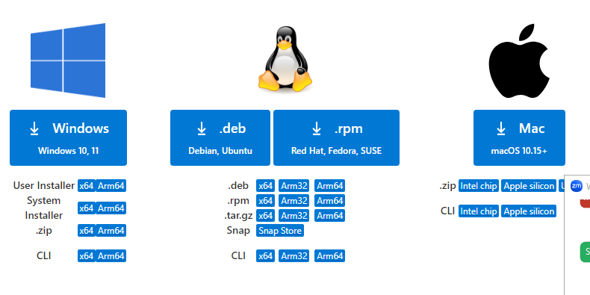
Extensions
- VScode icons
- Inteliescence CSS
- LiveServer

Server
Server is a program/software which serves resources to one or more than client. Server works based on two things
- Request (input)
- Response (Output)

Types of servers
- Local Server
- Cloud Server

Local Server
A server install in system is called local server
If application is installed in local server, it accessed by one person.

Cloud Server
Installing web application/web site on cloud server, which allows web application go live. It is accessed by the entire people worldwide.

Directory structure of web application or website

Web application or web site is collection of programs/resources. These resources are organized by following rules and regulations.

- Create project folder
  - Public
  - Src

All public resources are stored in public folder.
- Images
- Videos
- Audio
- Doc
- Html or htm
- Css
All server side programs are stored in src folder

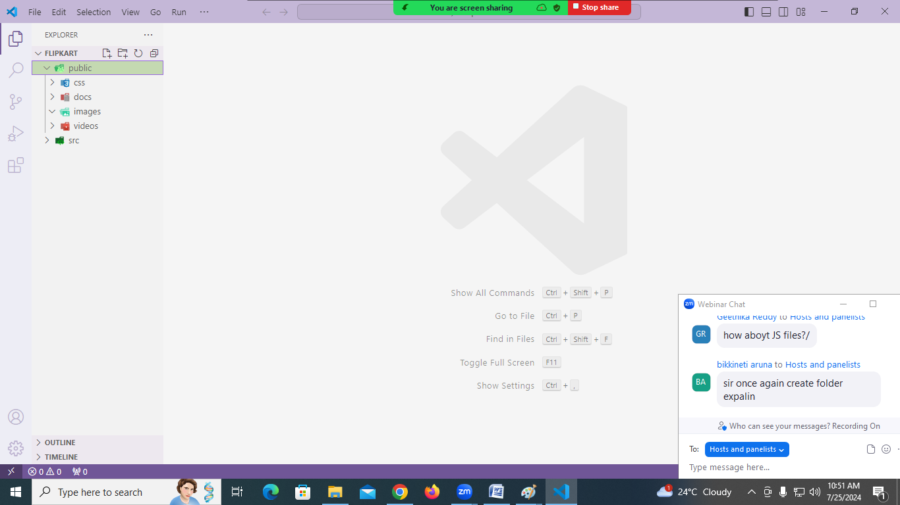

27/07/24
Q1: Explain directory structure of web application?
Web application/web site directory structured is divided into two folder
- Public
- Src
Public folder contains static files or static resource (images, audio, video, doc)
Src folder contains dynamic resources (css, javascript, java,…)

Q1: What is website?
Website/web application is virtual directory or path exists inside web server.
- Virtual path
- Physical path

Physical path
A local directory or location where all application resources are stored or saved.
Example: d:\flipcart

Virtual path
Always a website or web application is accessed using virtual path.
This virtual path is called URL Uniform resource locator.

This virtual path is created when web application/website go into live.

Note: Local server, virtual path is created by local server.

Q: What is ip-address?
Every computer or system in network is identified with unique number called ip-address.

Q: What is portno?
Every project within server is identified with unique number called portno.

What is webpage?
Web page is hyper text document which provides UI (User Interface) for accessing resources.

Hyper means beyond

Types of web pages
- Static page
- Dynamic page

Static page respond same for every user.
A page whose content does not change from one user to another user is called static page.
.html
.htm

Dynamic page respond different form users. These dynamic page required server side technologies

.jsp
.php
.asp
.aspx

HTML

HTML stands for Hyper Text Markup Language.
Markup language defines structure or layout of webpage (OR) markup language defines the presentation.

HTML 🡪 Creating Web Page
CSS 🡪 Cascading Style Sheet (styling web page)
JavaScript 🡪 developing interactive web page
Bootstrap 🡪 CSS library

What is browser?
Browser is a software used to communicate with web application.
Browser is thin-client software.
Brower is able to open any content (html, images, audio, video,..)

Example: Google Chrome, Edge, Mozilla Firefox

History of HTML

Telegram:
codewithsatishgupta
27/07/24
History of HTML

First marks language is introduced by CERN (European Council for Nuclear Research) whose is GML (Generalized Markup Language)

Later this language is improved and developed a language called SGML (Standardized Markup Language)

Tim Berners Lee introduced a language called HTML in early 1990’s
HTML is open source technology. HTML is superset of GML & SGML

A community name IETF (Internet Engineering Task Force), who maintained HTML upto HTML 3.0

Early 2004 a community name WHATWG is maintained HTML.
Previous version of HTML is 4.0 and current version of HTML 5 (2014)
WHATWG stands for Web Hypertext Application Technology Working Group.
Browser Architecture
Browser is a program/software which provides end user to communicate with website or web application or server

- Browser UI
- Persistence (Bookmarks, Cookies, …)
- Networking
- Browser Engine
- Render Engine
- Java script engine

Browser UI : Browser User Interface, provides facilities to communicate with browser.
Example: address bar, refresh, back, forward

Data Persistence: browser is able to persist or store data (cookies, Bookbamrks)

Networking : Browser establish communicate between client and server. Browser work with request/response.

Browser Engine: Browser engine responsibility is translating HTML and CSS understand by browser.

Render Engine: Render engine responsibility is displaying content within browser

Java script Translator: java script interpreter which translate and execute java script code.

HTML tags/elements
29/07/24
HTML is a markup language
HTML is used for presentation of data and providing UI for client/end User. It provides the user interface for accessing web resources.
HTML is used for creating web pages.
HTML provides tokens and these are called tags. Each tag represents one element.

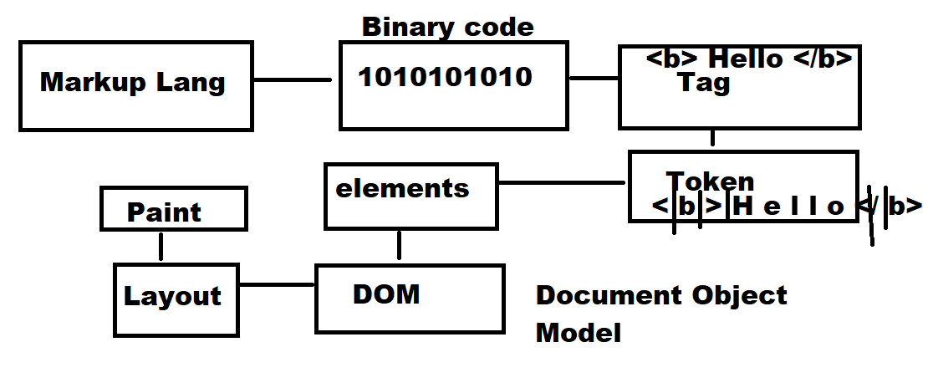
HTML elements are classified into 5 groups
- Normal elements
- Empty elements/void elements
- RC Data Elements
- Raw Text Elements
- Foreign Elements

Normal elements
An element which presents data without using any attributes.
This element required begins token/tag/element and end token/tag/element.
Normal elements return values

Example: <b>…</b>

Empty elements/void elements
Void elements required attributes to present data.
It does not return any value/data
Void elements do not have end tag/token

Example: <img>
RC Data elements
RC Data elements are called Rich Text Data elements.
These elements are used to represent plain text, numbers and other content.
RC data elements/tag does not allow nested tags/elements.

Example: <textarea> … </textarea>

Raw text elements
Raw text elements are presented using raw text; it does not required any tags.

Example:
&copy;
Amount &nbsp;&nbsp;&nbsp;&nbsp;&nbsp;&nbsp; is &#8377 45,000/-

Foreign Elements
These elements are not comes default with HTML.
These elements are available in library.
Library must be imported in order to use.

Example: Canvas

Web Page

Every page or html page is having extension .html or .htm

Note: tools can be used for creating web page
Example if web page is created using ms-word, this page is saved with .htm

- Define Document Definition/Declaration
Document definition tells the browser which language and version is used to develop webpage
This document definition is given using <!DOCTYPE html>
If HTML page is written in HTML 5.0, doctype is must.
<!DOCTYPE html>
codewithsatishgupta
pythonbygupta@gmail.com
30/07/24
2. Defining “document scope”

Document scope is defined using <html>…</html>
Every web page or document must start with <html> and end with </html>

Syntax:
<html>

</html>

If multiple documents defined inside html file/page, all these documents merged inside one document/web page.

<html> element is having an attribute called “lang”, this attribute defines language, date, time and currency format.

Syntax:
<html lang=”en-in”>
<html lang=”en-us”>
<html lang=”en-fr”>
<html lang=”en-uk”>

This document scope is divided into two parts
- head
- body

HTML document is divided into two parts 1. head 2.body

Syntax:
<html>
<head>
</head>

<body>
</body>
</html>
The content defined inside head is stored inside memory. Whenever browser required it read from memory, without reading from server. This avoids round trip.
This content defined inside body it does not store inside memory, whenever browser required it read from server.

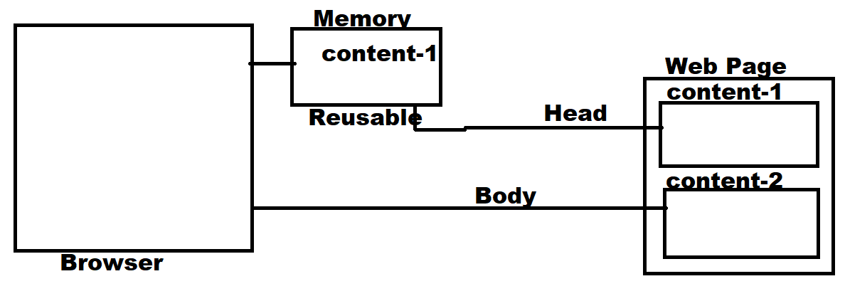

head

head tag is used to define,
- page title
- page is responsive
- seo friendly or seo optimization
- external resources
- scripting

<title>…</title>
This tag is defined inside head.
This tag is used to define page title, which is displayed on title bar.
This title also used in SEO Optimization.

Syntax: <title> … </title>

Example:
<!DOCTYPE html>
<html lang="en-in">
<head>
<title>Flipcart</title>
</head>
</html>

<link>
This tag is used to link external resources
- css files
- favicon
There can be multiple <link> tags within head.

What is favicon?
Icon is a image, which is displayed before title on title bar.
This image must have extension “ico”
This size of this image must be small (15x15px)

Syntax:
<link rel=’relation-type’ href=”resource name/path”>

Name of this image must favicon.ico or any other name. this image can be in png,ico formats.
31/07/24
The following tags are used inside <head> tag

- <title>
- <link>
- <meta>
- <script>
- <style>

meta

meta tag is used to define meta data.
Meta data is providing information data
meta tag defines information about web page
meta tag is used to make webpage responsive and SEO friendly

Responsive
Creating page responsive, the web page content fit according to devices and screen.
For making page as responsive there are various approaches and one of the approaches is using meta tag.

<meta name=”viewport” content=”width=device-width, initial-scale=1”>

viewport : it is nothing but on which device web page viewed
desktop, mobile, tab, samrtwatch

content : define the content should adjusted according to width of device.

Initial-scale : Zoom percentage 1 🡪 100% 1.5 🡪 150%

Note: this meta tag can be used more than one time

Testing webpage on simulator
Open Chrome
Search mobile simulator chrome extension and install

https://chromewebstore.google.com/detail/mobile-simulator-responsi/ckejmhbmlajgoklhgbapkiccekfoccmk

open chrome browser and type following URL for open project

http://127.0.0.1:5500/public/index.html

if you want test edge browser
click right mouse button on webpage and select inspect

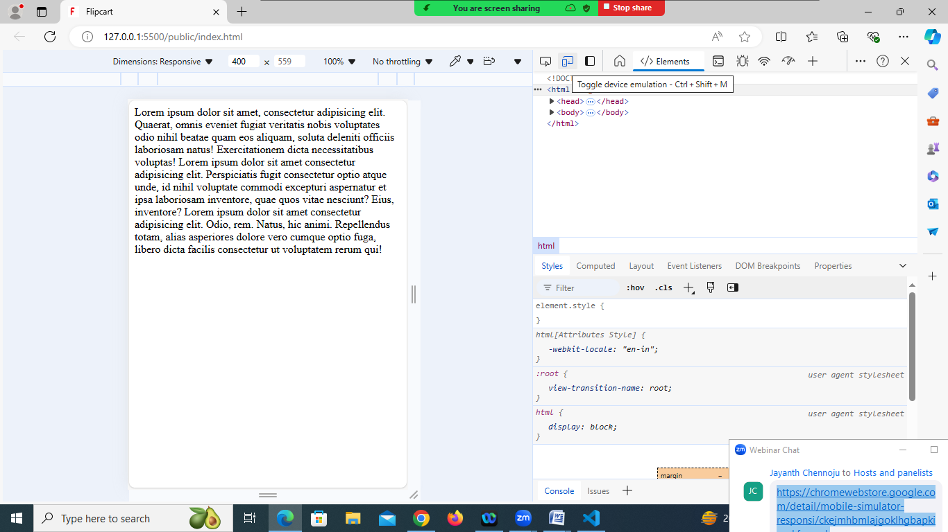

This tag is used to refresh the web page every 2 seconds

<meta http-equiv=”refresh” content=”2”>

SEO friendly

The webpage developed by programmer/web developer must be SEO friendly, it mean search engine must identify your web page.

<meta charset=”UTF-8”>

UTF stands UNICODE transformation Format, which define set characters used by web page

UTF-8 🡪 English (1byte – 8bits)
UTF -16,UTF-32,UTF-64 these are character set of other languages.

<!DOCTYPE html>
<html lang="en-in">
<head>
<title>Flipcart</title>
<link rel="icon" href="images/favicon1.png">
<meta name="viewport" content="width=device-width, initial-scale=2">
<meta http-equiv=”refresh” content=”5”>
</head>
<body>
Lorem ipsum dolor sit amet, consectetur adipisicing elit. Quaerat, omnis eveniet fugiat veritatis nobis voluptates odio nihil beatae quam eos aliquam, soluta deleniti officiis laboriosam natus! Exercitationem dicta necessitatibus voluptas!
Lorem ipsum dolor sit amet consectetur adipisicing elit. Perspiciatis fugit consectetur optio atque unde, id nihil voluptate commodi excepturi aspernatur et ipsa laboriosam inventore, quae quos vitae nesciunt? Eius, inventore?
Lorem ipsum dolor sit amet consectetur adipisicing elit. Odio, rem. Natus, hic animi. Repellendus totam, alias asperiores dolore vero cumque optio fuga, libero dicta facilis consectetur ut voluptatem rerum qui!

</body>
</html>

01/08/24
<meta name=”keywords” content=”keywords”>

This tag is used to define keywords

Example:
<meta name=”keywords” content=”java,oracle,HTML”>

<meta name=”description” content=”description”>
This tag is used to provide information about web page or web site.

Example:
<meta name=”description” content=”Best Training for HTML, CSS, JS, JAVA, PYTHON in Hyderabad”>

<style>…</style>
This tag is used for defining CSS styles

<style>

</style>

<script>…</script>
It is used to insert or embed java script code

<script>
Java script coding

</script>

body
The content of web page is defined inside body tag.
The content is displayed within browser as a part of web page.

Syntax:
<body>

</body>

In HTML4 version layout of the webpage or body is defined using tables. The problem with tables is, the content is loaded randomly.

In HTML 5 version they introduced semantic elements. The elements which are used for specific purpose are called semantic elements.
In HTML5 there are more than 100 semantic elements. These semantic elements are introduced to make your web page SEO friendly.

Example:
<header>
<footer>
<section>
<summary>
<nav>
<figure>
<time>
Etc…

Non semantic tags or elements
The elements which can be used for any purpose are called non semantic tags or elements.

- <div>
- <span>

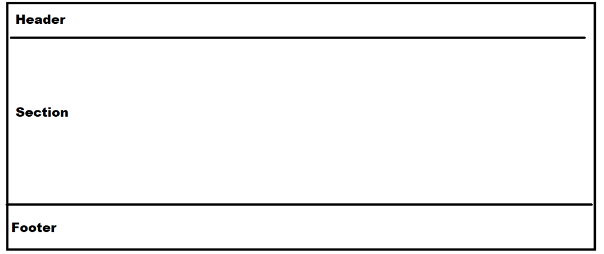

<div>

<div> is non semantic tag, it is used to organize related content by dividing into divisions.

<span>
This tag is used or embedded within line of text or continues text or elements.

Example:
<!DOCTYPE html>
<html lang="en">
<head>
<meta charset="UTF-8">
<meta name="viewport" content="width=device-width, initial-scale=1.0">
<title>Layout Demo</title>
<style>
div{
border: 2px black solid;
margin: 10px;
padding: 5px;
}
span
{
color:blue;
}
</style>
</head>
<body>
<div>
Full Stack Python
<div>
Module-1 Python
<div>
Core Python
<div>
Python <span>Language</span> Fundamentals
</div>
</div>
<div>
Adv Python
<div>
OOP, Database, Exceptions<br>
Files, GUI, Date Time
</div>
</div>
</div>
<div>
Module-2 FrontEnd
<div>
HTML
<div>
Creating Web Pages
</div>
<div>
CSS
<div>
Styling Web Pages
</div>
</div>
</div>
</div>
</div>
</body>
</html>

Attributes of body tag

02/08/24
Attributes of body tag
The following attributes are supported by body tag or element
- Bgcolor
- text
- Background
- Align
- Leftmargin
- Rightmargin
- Topmargin
- Bottonmargin
- Alink
- Vlink

bgcolor:
This attribute define the background color of body or webpage
These colors in HTML are represented in different formats
- Color name
  - Solid color names
  - Shading color names
- Color value

Solid color:
- Red
- Blue
- Green
- Pink
- Yellow
- Black
- White
Shade colors:
- Lightgreen
- Lightblue

Color Value:
R 🡪 Red 🡪 0-255
G 🡪 Green 🡪 0-255
B 🡪 Blue 🡪 0-255
Color value is represented in two formats
- Single digit format
- Double digit format
This color value is prefix with #
This color value technically are called hexacode(hexadecimal value format)

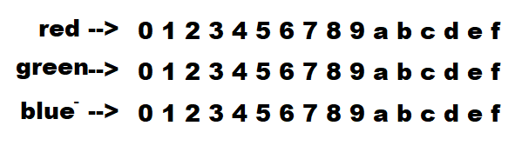
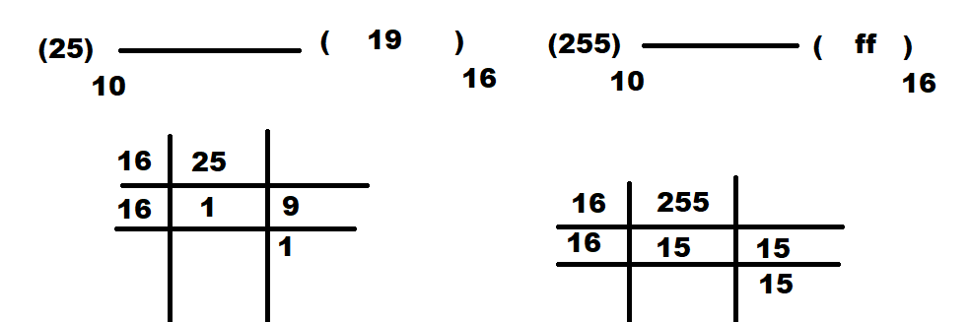

Example:
<body bgcolor=”red”>
<body bgcolor=”yellow”>
<body bgcolor=”lightblue”>
<body bgcolor=”#00f”>
<body bgcolor=”#a0b”>
<body bgcolor=”#a10000”>
<body bgcolor=”#aa00bb”>

text
This attribute is used to define font color or text color

Example:
<body text=”red”>
<body text=”#00ff00”>

background

This attribute is used to define background image

Syntax:
<body background=”images/imagename”>

Image can be style used css styles
- Background-size
- Background-repeat
- Background-position
- Background-attachment

Syntax:
<style>
body
{
Background-size: width,height,cover,contain
Background-position: top, bottom, left, right,center
Background-repeat: no-repeat,repeat,repeat-x,repeat-y
Background-attachment : scroll,fixed
}

align

This is used for alignment of text
The value of alignment is
- Left
- Right
- Center
- Justify

<!DOCTYPE html>
<html lang="en">
<head>
<meta charset="UTF-8">
<meta name="viewport" content="width=device-width, initial-scale=1.0">
<title>Layout Demo</title>
<style>
div{
border: 2px black solid;
margin: 10px;
padding: 5px;
}
body
{
height: 100vh;
background-repeat: no-repeat;
background-position: center center;
background-size: 500px 500px;
background-attachment:fixed;
}

</style>
</head>
<body background="images/banner.avif" text="yellow">
<div>
Full Stack Python
<div>
Module-1 Python
<div>
Core Python
<div>
Python <span>Language</span> Fundamentals
</div>
</div>
<div>
Adv Python
<div>
OOP, Database, Exceptions<br>
Files, GUI, Date Time
</div>
</div>
</div>
<div>
Module-2 FrontEnd
<div>
HTML
<div>
Creating Web Pages
</div>
<div>
CSS
<div>
Styling Web Pages
</div>
</div>
</div>
</div>
</div>
<div>
Full Stack Python
<div>
Module-1 Python
<div>
Core Python
<div>
Python <span>Language</span> Fundamentals
</div>
</div>
<div>
Adv Python
<div>
OOP, Database, Exceptions<br>
Files, GUI, Date Time
</div>
</div>
</div>
<div>
Module-2 FrontEnd
<div>
HTML
<div>
Creating Web Pages
</div>
<div>
CSS
<div>
Styling Web Pages
</div>
</div>
</div>
</div>
</div>
</body>
</html>

03/08/24
align

This is used for alignment of text
The value of alignment is
- Left
- Right
- Center
- Justify

Alignment defines the flow of text within body.

Left 🡪 align text within body from left to right. In left alignment flow of text is from left to right.
Right 🡪 align text within body from right to left. In right alignment flow of text is from right to left
Center 🡪 align text within body in the middle or center. In center alignment the flow of text is from center to left and right.
Justify 🡪 align text within body according to width.

<!DOCTYPE html>
<html lang="en">
<head>
<meta charset="UTF-8">
<meta name="viewport" content="width=device-width, initial-scale=1.0">
<title>Document</title>
</head>
<body align="justify">
Lorem ipsum, dolor sit amet consectetur adipisicing elit. Quas similique illum sunt sed praesentium a sint quidem non accusamus in hic iste, necessitatibus voluptas qui voluptatem vitae expedita nam at.
Lorem ipsum dolor sit amet consectetur, adipisicing elit. Numquam molestiae harum animi nesciunt similique quisquam sapiente! Deleniti vitae eligendi corporis ducimus earum ea praesentium eos officiis. Laudantium laborum in adipisci.
Lorem ipsum dolor sit amet consectetur adipisicing elit. Nobis dolorum iste iure neque cumque optio mollitia ab deserunt odit accusamus quos, incidunt tempora eaque, labore itaque accusantium molestias, blanditiis nesciunt.
Lorem ipsum dolor sit amet consectetur adipisicing elit. Ratione ipsam qui porro vero, ad possimus sunt. Magni itaque ab voluptate omnis mollitia, veniam error fugit placeat odio aliquam nam <ipsa class="lo"></ipsa>
</body>
</html>

Margins

The margin is nothing but space given from page border to content.
This margin is set using 4 attributes
- Leftmargin
- Righmargin
- Topmargin
- Bottommargin

Syntax:
<body leftmargin=<value>,rightmargin=<value>,topmargin=<value>,bottommargin=<value> >

Content

</body>

This margins sets the space between page border and content.

Example:
<body leftmargin=”50” topmargin=”50”>

Content

</body>

alink 🡪 This attribute is used to set active link color
vlink 🡪 This attribute is used to set visited link color

<!DOCTYPE html>
<html lang="en">
<head>
<meta charset="UTF-8">
<meta name="viewport" content="width=device-width, initial-scale=1.0">
<title>Document</title>
</head>
<body vlink="green" alink="red">
<a href="https://www.nareshit.com">NareshIt</a><br>
<a href="http://www.google.com">Google</a>
<a href="http://www.facebook.com">Facebook</a>

</body>
</html>

- Bgcolor
- Text
- Background
- Align
- Leftmargin
- Rightmargin
- Topmargin
- Bottommargin
- Alink
- Vlink

05/08/24
<header>..</header>

<header> is semantic element/tag used for defining headers.
This header contains navigation, logo/image, heading and authentication, search bar, header tags.
Header element is SEO friendly.
In webpage, a developer can be define multiple header semantics

Syntax:
<header>
tags
</header>

CSS styles

CSS style attributes for text formatting/style

- font-size : it sets size of the character
- font-family : it set font name default is (Arial,Script)
- color : it sets text color
- font-weight : sets bold
- font-style : sets italic

Syntax:
{
font-size: size;
font-family:font-name;
color:color;
font-weight:bold;
font-style:italic;
}

CSS styles for margins and padding
The following attributes are used for margins and padding

margin: sets left, right, top, bottom margin
margin-left : sets left margin
margin-right : sets right margin
margin-top : sets top margin
margin-bottom : sets bottom margin

padding : sets left,right,bottom,top padding
padding-left : sets left padding
padding-right: sets right padding
padding-top : sets top padding
padding-bottom : sets bottom padding

Margin is space from page border to border
Padding is space from border to content

CSS styles for borders

border: size style color
border-top : sets top border
border-left :sets left border
border-right: sets right border
border-bottom: sets bottom border

size is thickness of border
style how border should be (dotted, doubled, solid,..)
color define border color

border-radius

This attribute defines border radius

Syntax:
{
Border-radius: sets radius for all the borders (left-top, left-bottom, right-top, right-bottom)
Border- top-left radius:
Border-top-right- radius:
Border-bottom-left-radius:
Border-bottom-right-radius:

}

CSS display styles

06/08/24
Bootstrap icons
Bootstrap is CSS library.
In order to work with bootstrap icons use the following steps
- Install nodejs
  - To use package manger called npm (node package manager), it is used for managing packages(libraries)
Note: npm stands for node package manger

How verify node is installed or not?
- Open command prompt

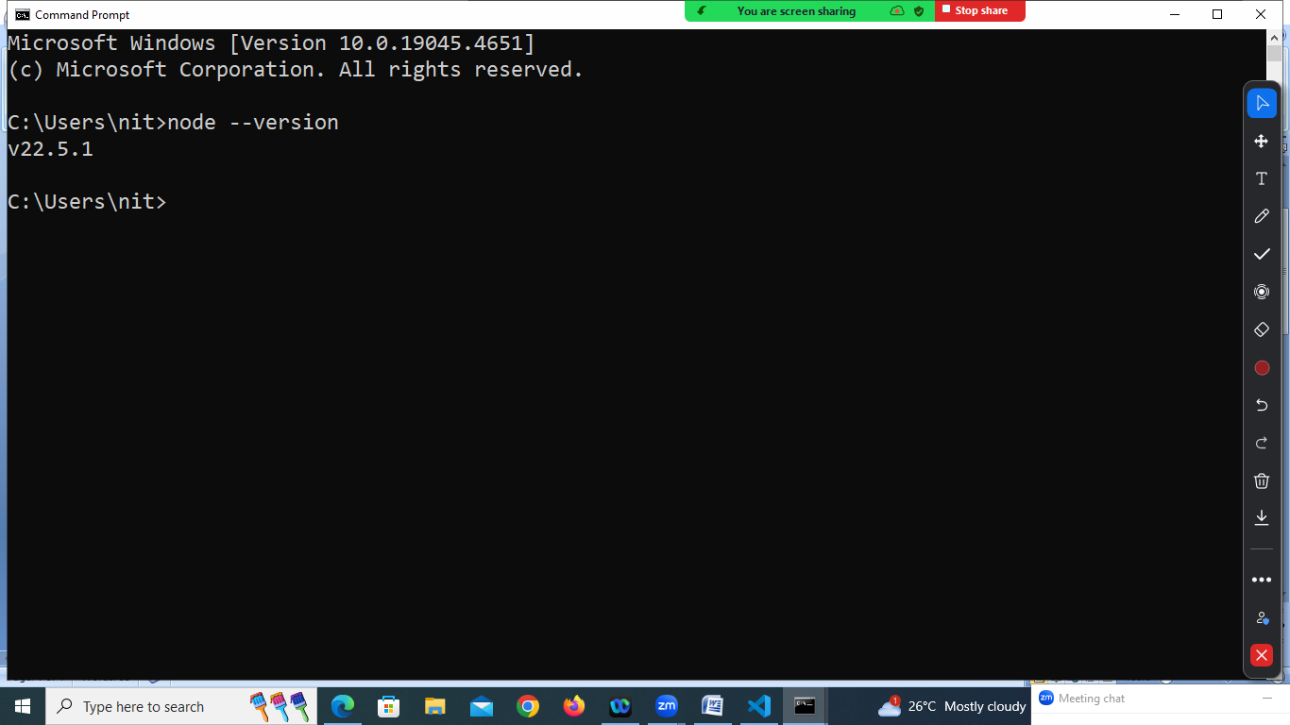

Open vscode
Open terminal
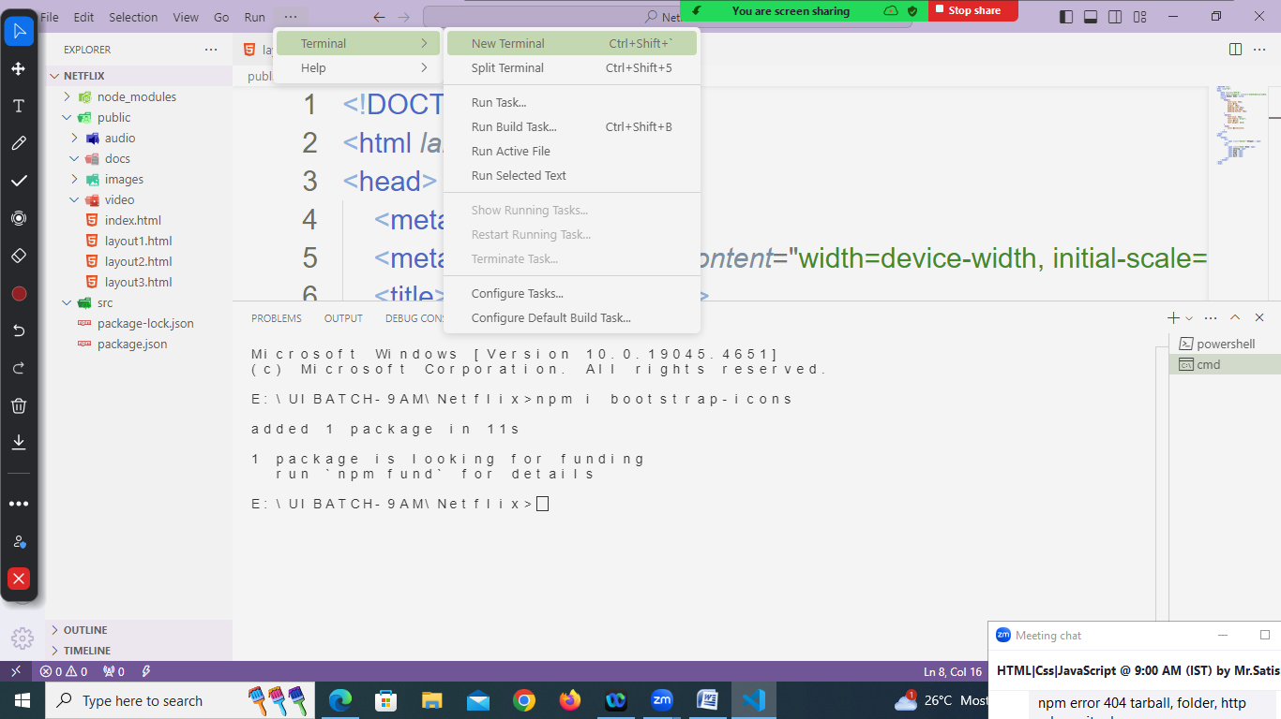

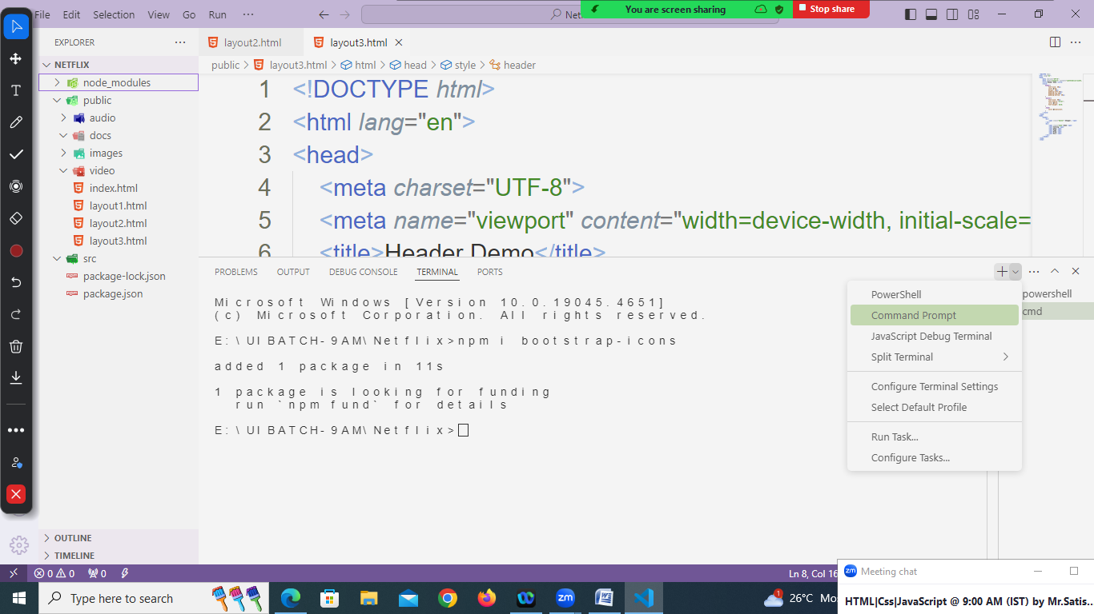

CSS display styles

display:none : hide element
display:inline : it will display element side by side without effects (size,format)
display:block : it will display element one after another
display:inline block : it will display elements side by side with effects
(size and format)
Display:flex : it can display inline or block
Flex-direction : row
Flex-direction: column

<!DOCTYPE html>
<html lang="en">
<head>
<meta charset="UTF-8">
<meta name="viewport" content="width=device-width, initial-scale=1.0">
<title>Header Demo</title>
<link rel="stylesheet" href="../node_modules/bootstrap-icons/font/bootstrap-icons.min.css">
<style>
header{
font-size: 30px;
margin: 20px;
padding-left:20px;
padding-top:20px;
padding-bottom: 20px;
display: flex;
flex-direction: row;
justify-content:space-evenly;
}
.banner{
font-size: 50px;
font-family:"arial";
font-weight: bold;
}

</style>
</head>
<body>
<header>
<div>
<span class="banner">Shopper.</span>
</div>
<div >
<nav>
<span>Home</span>
<span>Catalog</span>
<span>Shop</span>
<span>Page</span>
<span>Blog</span>
<span>Docs</span>
</nav>
</div>
<div>
<span class="bi bi-search"></span>
<span class="bi bi-person"></span>
<span class="bi bi-heart"></span>
<span class="bi bi-cart"></span>
</div>
</header>
</body>
</html>

07/08/24
<!DOCTYPE html>
<html lang="en">
<head>
<meta charset="UTF-8">
<meta name="viewport" content="width=device-width, initial-scale=1.0">
<title>Header Demo</title>
<link rel="stylesheet" href="../node_modules/bootstrap-icons/font/bootstrap-icons.min.css">
<style>
header{
font-size: 25px;
margin:10px;
padding-top:10px;
display: flex;
flex-direction: row;
justify-content:space-between;
}
.banner{
font-size: 35px;
font-family:"arial";
font-weight: bold;
}
.navbar span {
padding-right: 20px;
}
.icons span {
padding-right: 20px;
}
</style>
</head>
<body>
<header>
<div>
<span class="banner">Shopper.</span>
</div>
<div class="navbar" >

<span>Home</span>
<span>Catalog</span>
<span>Shop</span>
<span>Page</span>
<span>Blog</span>
<span>Docs</span>

</div>
<div class="icons">
<span class="bi bi-search"></span>
<span class="bi bi-person"></span>
<span class="bi bi-heart"></span>
<span class="bi bi-cart"></span>
</div>
</header>
</body>
</html>

<!DOCTYPE html>
<html lang="en">
<head>
<meta charset="UTF-8">
<meta name="viewport" content="width=device-width, initial-scale=1.0">
<link rel="stylesheet" href="../node_modules/bootstrap-icons/font/bootstrap-icons.min.css">
<title>SELL</title>
<style>
header{
display:flex;
justify-content: space-between;
margin-top: 40px;
border: 2px solid black;
padding: 20px;
background-color: bisque;
}
span{
padding-right: 10px;
}
.logo
{
font-size: 30px;
font-family: Arial, Helvetica, sans-serif;
}
.nav_bar
{
font-size: 20px;
}
</style>
</head>
<body>
<header>
<div class="logo">
<span>SELL.</span>
</div>
<div>
<nav class="nav_bar">
<span>HOME</span><span class="bi bi-chevron-down"></span>
<span>SHOP</span><span class="bi bi-chevron-down"></span>
<span>TEMPLATE</span><span class="bi bi-chevron-down"></span>
<span>DROPDOWN</span><span class="bi bi-chevron-down"></span>
<span>CONTACT</span>
<span>DOCS</span><span class="bi bi-chevron-down"></span>
</nav>
</div>
<div>
<span class="bi bi-search"></span>
<span class="bi bi-person-circle"></span>
<span class="bi bi-cart"></span>

</div>
</header>
</body>
</html>

<!DOCTYPE html>
<html lang="en">
<head>
<meta charset="UTF-8">
<meta name="viewport" content="width=device-width, initial-scale=1.0">
<title>LandKit</title>
<style>
header{
display:flex;
justify-content: space-evenly;
margin-top: 40px;
}
.logo
{
font-size: 30px;
font-weight: bold;
color:blue;
}
nav
{
font-size:25px;
}
.btn
{
font-size: 25px;
border:2px solid blue;
color:white;
background-color: blue;

}
span
{
padding-right: 20px;
}
</style>
</head>
<body>
<header>
<div class="logo">
<span>LandKit.</span>
</div>
<div>
<nav>
<span>Landings</span>
<span>Pages</span>
<span>Account</span>
<span>Documentation</span>

</nav>

</div>
<div>
<span class="btn">Buy Now</span>
</div>

</header>
</body>
</html>

08/08/24
CSS Colors
CSS provides various approaches for representation of colors
- Color name
- Shade Name
- Hexa Code/HexaDecimal Value
- rgb() function
- rgba() function
- hsl() function
- hsla() function
- linear-gradient
- radial-gradient

- Color Name
Each color in css represented as keyword.
- Red
- Blue
- Green
- Yellow
- Cyan
- Pink

- Shade Name
Shade name is represented as keyword

- Darkgreen
- Darkred
- Lightgreen
- Lightred

- HexaCode

Color value is represented in hexacode
- 1 2 3 4 5 6 7 8 9 a b c d e f
Hexacode is represented in one digit or two digits

#000 #f00 #0f0 #00f #abc

Two digits format is used for representing colors ranges from 0-255

#00ff00 #ab1245

- rgb() function

CSS provides rgb function to represent color
Syntax: rgb(red,green,blue)

Example:
{
Backround_color:rgb(100,50,120);
}

- rgba(red,green,blue,alpha)

alpha represent transparent.
This transparent value range from 0-1

Example:
<!DOCTYPE html>
<html lang="en">
<head>
<meta charset="UTF-8">
<meta name="viewport" content="width=device-width, initial-scale=1.0">
<title>Color Demo</title>
<style>
body
{
background-size: cover;
background-repeat: no-repeat;
}
div
{
height: 100vh;
background-color: rgba(0,0,0,0.7);
font-size:30px;
color:white;
text-align: center;
}
</style>
</head>
<body background="images/banner.avif">
<div>
This Text is inside Division
</div>
</body>
</html>

- hsl() function

This function returns color value using
H : Hue
S : saturation
L : lightness

Hue : It is a color angle from 0 to 360 deg
0-120 🡪 red
120-240 🡪 green
240-360 🡪 blue
Saturation: it control “gray” color from 1% to 100%
Lightness: it control brightness from 1% to 100%

Example:
{
Background-color:hsl(120deg,70%,50%);
}

- hsla() function

This function returns color value using
H : Hue
S : saturation
L : lightness
a : alpha (0-1) transparent

Example:
Example:
{
Background-color:hsla(120deg,70%,50%,0.5);
}

<!DOCTYPE html>
<html lang="en">
<head>
<meta charset="UTF-8">
<meta name="viewport" content="width=device-width, initial-scale=1.0">
<title>Color Demo</title>
<style>
body
{
background-size: cover;
background-repeat: no-repeat;
}
div
{
height: 100vh;
background-color: hsla(0,50%,30%,0.5);
}
</style>
</head>
<body background="images/banner.avif">
<div>

</div>
</body>
</html>

- linear-gradient
- radial-gradient

we can put gradient colors only using backround-image property or attribute

Syntax
{
Background-image:linear_gradient() or radial_gradient()
}

<!DOCTYPE html>
<html lang="en">
<head>
<meta charset="UTF-8">
<meta name="viewport" content="width=device-width, initial-scale=1.0">
<title>Color Demo</title>
<style>
body
{
background-image: radial-gradient(red,yellow,green)
}
</style>
</head>
<body>

</body>
</html>

09/08/24
section

section is semantic element in HTML.
section element is defined between header and footer.
section defines the content which is displayed between header and footer.

Syntax:
<body>
<header>
</header>
<section>
</section>
<footer>
</footer>
</body>

main

main is called semantic element in HTML5
main is consider as entry point of webpage/website
main defines the content which is used by end user/client to start using website. (where user can start)
A page may contains multiple main semantic elements.
This element is defined inside section.

Syntax:
<body>
<header>
</header>
<section>
<main>
</main>
</section>
<footer>
</footer>
</body>
<!DOCTYPE html>
<html lang="en">
<head>
<meta charset="UTF-8">
<meta name="viewport" content="width=device-width, initial-scale=1.0">
<link rel="stylesheet" href="../node_modules/bootstrap-icons/font/bootstrap-icons.min.css"
<title>NetFlix</title>
<style>
body
{
background-size: cover;
background-repeat: no-repeat;
height: 100vh;
}
.cover
{
background-color:rgba(0,0,0,0.7) ;
height: 100vh;
margin: -20px;

}
header
{
color:white;
font-family: Arial;
padding:60px;
display:flex;
justify-content:space-around;
}
.brand-name
{
color:red;
font-size: 40px;
font-weight: bold;
}
.language
{
border:1px solid white;
padding:5px;
}
.btn-signin
{
border:1px solid red;
font-size: 20px;
margin-left: 20px;
background-color: red;
border-radius: 5px;
width:100px;
height:30px ;
display:inline-block;
text-align: center;
padding-top: 5px;
}
section
{
color:white;
font-family: Arial;
text-align: center;
margin-top: 120px;
}
.text1
{
font-size: 45px;
font-weight: bold;
margin-bottom: 10px;
}
.text2
{
font-size: 20px;
}
.text3
{
font-size: 20px;
margin-bottom: 50px;
}
main {
margin-top: 25px;
font-family: Arial;
font-size:20px;
}
.email
{
border:1px solid gray;
background-color: rgba(0,0,0,0.7);
padding:10px;
width:350px;
display:inline-block;
color:gray;
}
.start-btn
{
border:1px solid red;
background-color: red;
color:white;
padding:10px;
width:200px;
border-radius: 5px;
}
</style>
</head>
<body background="images/netflix-banner.jpeg">
<div class="cover">
<header>
<div class="brand-name">
<span>NETFLIX</span>
</div>
<div>
<span class="language">
<span class="bi bi-translate"></span>
<span>English</span>
<span class="bi bi-chevron-down"></span>
</span>
<span class="btn-signin">
Signin
</span>
</div>
</header>
<section>
<div class="text1">Unlimited movies, TV shows and more</div>
<div class="text2">Watch anywhere. Cancel anytime.</div>
<main>
<div class="text3"> Ready to watch? Enter your email to create or restart your membership.
</div>
<div>
<span class="email">Email Address</span>
<span class="start-btn">
<span>Get Started</span><span class="bi bi-chevron-right"></span>
</span>
</div>
</main>

</section>
</div>
</body>
</html>

10/08/24/
<article> element

<article> is a semantic element HTML5
The <article> HTML element represents a self-contained composition in a document, page, application, or site, which is intended to be independently distributable or reusable (e.g., in syndication). Examples include: a forum post, a magazine or newspaper article, or a blog entry, a product card, a user-submitted comment, an interactive widget or gadget, or any other independent item of content.

Syntax:
<article>
</article>

footer element

footer is semantic element HTML5
it is used to define footer information of web page
A <footer> typically contains information about the author of the section, copyright data or links to related documents and contact.

Syntax:
<footer>
</footer>

Example:
<!DOCTYPE html>
<html lang="en">
<head>
<meta charset="UTF-8">
<meta name="viewport" content="width=device-width, initial-scale=1.0">
<title>Header Demo</title>
<link rel="stylesheet" href="../node_modules/bootstrap-icons/font/bootstrap-icons.min.css">
<style>
header{
font-size: 25px;
margin:10px;
padding-top:10px;
display: flex;
flex-direction: row;
justify-content:space-between;
}
.banner{
font-size: 35px;
font-family:"arial";
font-weight: bold;
}
.navbar span {
padding-right: 20px;
}
.icons span {
padding-right: 20px;
}
article
{
background-color: black;
color:white;
font-size: 25px;
padding:15px;
text-align: center;
}
article span{
color:darkgoldenrod;
}
.deals
{
color:white;
}
footer
{
margin-top: 200px;
background-color: black;
color:white;
text-align: center;
font-family: Arial;
padding-top:50px;
height: 200px;
}
.footer-want
{
font-size: 25px;

}
.footer-email
{
border:1px solid black;
background-color: rgb(65, 64, 64);
width:350px;
display:inline-block;
padding:20px;
text-align: left;
font-size: 15px;
color:gray;
}
.footer-sub-btn
{
border:1px solid black;
background-color: rgb(65, 64, 64);
color:white;
width:100px;
display:inline-block;
padding: 20px;
font-family: Arial, Helvetica, sans-serif;
}
.footer1
{
margin-top: 30px;
}
</style>
</head>
<body>
<header>
<div>
<span class="banner">Shopper.</span>
</div>
<div class="navbar" >

<span>Home</span>
<span>Catalog</span>
<span>Shop</span>
<span>Page</span>
<span>Blog</span>
<span>Docs</span>

</div>
<div class="icons">
<span class="bi bi-search"></span>
<span class="bi bi-person"></span>
<span class="bi bi-heart"></span>
<span class="bi bi-cart"></span>
</div>
</header>
<article>
<span class="bi bi-lightning-charge-fill" ></span>
<span class="deals">Happy Holiday Deals on Everything </span>
<span class="bi bi-lightning-charge-fill"></span>
</article>

<footer>
<div class="footer-want">Want style Ideas and Treats?</div>
<div class="footer1">
<span class="footer-email">Enter Email*</span>
<span class="footer-sub-btn">Subscribe</span>
</div>
<div>
<div>
<span>Shopper</span>
<span class="bi bi-facebook"></span>
<span class="bi bi-youtube"></span>
<span class="bi bi-twitter"></span>
<span class="bi bi-instagram"></span>
<span class="bi bi-medium"></span>
</div>
<div>

</div>
<div>

</div>
<div>

</div>
<div>

</div>
<div>

</div>
</div>

</footer>
</body>
</html>

12/08/24
CSS grid

CSS grid display organize items in rows and columns
This grid can be configured using css display properties “display:grid”
Grid can arrange items or elements in rows or columns by using grid template property

- grid-template-rows
- grid-template-columns

Syntax
{
Display:grid;
Grid-templates-rows:
grid-template-columns:
}

This rows and columns are divided in fixed size or responsive size.
Fixed size is represented in pixels
Responsive size is represented in fractional

The default screen width is 1200px or 12fr
Px 🡪 represents pixels
Fr 🡪 represents fractional
Example
{
display:grid;
grid-template-columns: 300px 300px 300px 300px
}

Example
{
display:grid:
grid-template-columns: 3fr 3fr 3fr 3fr
}

Example:
{
display:grid;
grid-template-columns:4fr 4fr 4fr;
}
Example:
{
Display:grid;
Grid-template-columns:2.5fr 2.5fr 2.5fr 2.5fr 2.5fr;
}

Example:
<!DOCTYPE html>
<html lang="en">
<head>
<meta charset="UTF-8">
<meta name="viewport" content="width=device-width, initial-scale=1.0">
<title>Header Demo</title>
<link rel="stylesheet" href="../node_modules/bootstrap-icons/font/bootstrap-icons.min.css">
<style>
header{
font-size: 25px;
margin:10px;
padding-top:10px;
display: flex;
flex-direction: row;
justify-content:space-between;
}
.banner{
font-size: 35px;
font-family:"arial";
font-weight: bold;
}
.navbar span {
padding-right: 20px;
}
.icons span {
padding-right: 20px;
}
article
{
background-color: black;
color:white;
font-size: 25px;
padding:15px;
text-align: center;
}
article span{
color:darkgoldenrod;
}
.deals
{
color:white;
}
footer
{
margin-top: 200px;
background-color: black;
color:white;
font-family: Arial;
padding-top:50px;
height: 300px;
}
.footer-want
{
font-size: 25px;
text-align: center;

}
.footer-email
{
border:1px solid black;
background-color: rgb(65, 64, 64);
width:350px;
display:inline-block;
padding:20px;
text-align: left;
font-size: 15px;
color:gray;
}
.footer-sub-btn
{
border:1px solid black;
background-color: rgb(65, 64, 64);
color:white;
width:100px;
display:inline-block;
padding: 20px;
font-family: Arial, Helvetica, sans-serif;
}
.footer1
{
margin-top: 20px;
text-align: center;
}
.service-title
{
font-size: 20px;
font-weight: bold;
margin-bottom: 10px;
}
.services
{
display: grid;
grid-template-columns:2.5fr 2.5fr 2.5fr 2.5fr 2.5fr;
margin: 50px;

}
.services span {
display:block;
color:gray;
font-family: Arial;
}
.smedia {
display:flex;
justify-content:space-evenly;
}
</style>
</head>
<body>
<header>
<div>
<span class="banner">Shopper.</span>
</div>
<div class="navbar" >

<span>Home</span>
<span>Catalog</span>
<span>Shop</span>
<span>Page</span>
<span>Blog</span>
<span>Docs</span>

</div>
<div class="icons">
<span class="bi bi-search"></span>
<span class="bi bi-person"></span>
<span class="bi bi-heart"></span>
<span class="bi bi-cart"></span>
</div>
</header>
<article>
<span class="bi bi-lightning-charge-fill" ></span>
<span class="deals">Happy Holiday Deals on Everything </span>
<span class="bi bi-lightning-charge-fill"></span>
</article>

<footer>
<div class="footer-want">Want style Ideas and Treats?</div>
<div class="footer1">
<span class="footer-email">Enter Email*</span>
<span class="footer-sub-btn">Subscribe</span>
</div>
<div class="services">
<div>
<span class="service-title">Shopper</span>
<div class="smedia">
<span class="bi bi-facebook"></span>
<span class="bi bi-youtube"></span>
<span class="bi bi-twitter"></span>
<span class="bi bi-instagram"></span>
<span class="bi bi-medium"></span>
</div>
</div>
<div>
<span class="service-title">SUPPORT</span>
<span>Contact Us</span>
<span>FAQs</span>
<span>Size Guide</span>
<span>Shipping & Returns</span>
</div>
<div>
<span class="service-title">SHOP</span>
<span> Men's Shopping</span>
<span>Women's Shopping</span>
<span>Kids' Shopping</span>
<span>Discounts</span>
</div>
<div>
<span class="service-title">COMPANY</span>

<span> Our Story</span>
<span>Careers</span>
<span>Terms & Conditions</span>
<span>Privacy & Cookie Policy</span>

</div>
<div>
<span class="service-title">CONTACT</span>

<address>
<span> 1-202-555-0105 </span>
<span>1-202-555-0106</span>
<span>help@shopper.com</span>

</address>

</div>
</div>
</footer>
</body>
</html>

Example:
<!DOCTYPE html>
<html lang="en">
<head>
<meta charset="UTF-8">
<meta name="viewport" content="width=device-width, initial-scale=1.0">
<title>Document</title>
<style>
footer
{
height:200px;
background-color: black;
color: white;
font-family: Arial;

margin-top: 100px;
}
.back
{
background-color: gray;
text-align: center;

font-size: 20px;

}
.services
{
display:grid;
grid-template-columns: 3fr 3fr 3fr 3fr;
}
.title
{
font-size: 15px;
font-weight: bold;
}
.services span {
display:block;
padding-top:10px ;
}
</style>
</head>
<body>
<footer>
<div class="back">
<span >Back to Top</span>
</div>
<div class="services">
<div>
<span class="title">Get to Know Us</span>
<span>About Us</span>
<span>Careers</span>
<span>Press Releases</span>
<span>Amazon Science</span>
</div>
<div>
<span class="title">Connect with Us</span>
<span>Facebook</span>
<span>Twitter</span>
<span>Instagram</span>
</div>
<div>
<span class="title">Make Money with Us</span>
<span>Sell on Amazon</span>
<span>Sell under Amazon Accelerator</span>
<span>Protect and Build Your Brand</span>
<span>Amazon Global Selling</span>
<span>Become an Affiliate</span>

</div>
<div>

<span class="title"> Let Us Help You</span>
<span> COVID-19 and Amazon</span>
<span> Your Account</span>
<span> Returns Centre</span>
</div>

</div>
</footer>
</body>
</html>

- header
- footer
- main
- nav
- address
- article
- section

13/08/24
css image properties

container
{
background-image: url(path);
background-size:cover,size;
background-repeat:repeat or no-repeat;
background-postion:center center;
background-attatchment: fixed;
}

<!DOCTYPE html>
<html lang="en">
<head>
<meta charset="UTF-8">
<meta name="viewport" content="width=device-width, initial-scale=1.0">
<title>Header Demo</title>
<link rel="stylesheet" href="../node_modules/bootstrap-icons/font/bootstrap-icons.min.css">
<style>
header{
font-size: 25px;
margin:10px;
padding-top:10px;
display: flex;
flex-direction: row;
justify-content:space-between;
}
.banner{
font-size: 35px;
font-family:"arial";
font-weight: bold;
}
.navbar span {
padding-right: 20px;
}
.icons span {
padding-right: 20px;
}
article
{
background-color: black;
color:white;
font-size: 25px;
padding:15px;
text-align: center;
margin-bottom: 5px;
}
article span{
color:darkgoldenrod;
}
.deals
{
color:white;
}
footer
{
margin-top: 10px;
background-color: black;
color:white;
font-family: Arial;
padding-top:50px;
height: 300px;
}
.footer-want
{
font-size: 25px;
text-align: center;

}
.footer-email
{
border:1px solid black;
background-color: rgb(65, 64, 64);
width:350px;
display:inline-block;
padding:20px;
text-align: left;
font-size: 15px;
color:gray;
}
.footer-sub-btn
{
border:1px solid black;
background-color: rgb(65, 64, 64);
color:white;
width:100px;
display:inline-block;
padding: 20px;
font-family: Arial, Helvetica, sans-serif;
}
.footer1
{
margin-top: 20px;
text-align: center;
}
.service-title
{
font-size: 20px;
font-weight: bold;
margin-bottom: 10px;
}
.services
{
display: grid;
grid-template-columns:2.5fr 2.5fr 2.5fr 2.5fr 2.5fr;
margin: 50px;

}
.services span {
display:block;
color:gray;
font-family: Arial;
}
.smedia {
display:flex;
justify-content:space-evenly;
}
.main
{
display:grid;
grid-template-columns: 4fr 4fr 4fr;
font-size: 30px;
color:white;

}
.women
{
background-image: url(images/women-banner.avif);
background-size: cover;
height: 500px;
display:flex;
flex-direction: column;
justify-content: space-around;
align-items: center;
}
.ban{
font-size: 50px;
font-family: Arial;
font-weight: bold;
}

.men
{
background-image: url(images/men-banner.avif);
background-size: cover;
display:flex;
flex-direction: column;
justify-content: space-around;
align-items: center;

}
.kids
{
background-image: url(images/kids-banner.avif);
background-size: cover;
display:flex;
flex-direction: column;
justify-content: space-around;
align-items: center;
}
.btn{
border: 1px solid white;
background-color: white;
color:black;
padding:15px;
font-size: 15px;
}
</style>
</head>
<body>
<header>
<div>
<span class="banner">Shopper.</span>
</div>
<div class="navbar" >

<span>Home</span>
<span>Catalog</span>
<span>Shop</span>
<span>Page</span>
<span>Blog</span>
<span>Docs</span>

</div>
<div class="icons">
<span class="bi bi-search"></span>
<span class="bi bi-person"></span>
<span class="bi bi-heart"></span>
<span class="bi bi-cart"></span>
</div>
</header>
<article>
<span class="bi bi-lightning-charge-fill" ></span>
<span class="deals">Happy Holiday Deals on Everything </span>
<span class="bi bi-lightning-charge-fill"></span>
</article>
<section>
<div class="main">
<div class="women">
<span class="ban">Women</span>
<span class="btn">Shop Women</span>
</div>
<div class="men">
<span class="ban">Men</span>
<span class="btn">Mens Shoping</span>
</div>
<div class="kids">
<span class="ban"> Kids</span>
<span class="btn">Kids Shoping</span>
</div>
</div>

</section>
<footer>
<div class="footer-want">Want style Ideas and Treats?</div>
<div class="footer1">
<span class="footer-email">Enter Email*</span>
<span class="footer-sub-btn">Subscribe</span>
</div>
<div class="services">
<div>
<span class="service-title">Shopper</span>
<div class="smedia">
<span class="bi bi-facebook"></span>
<span class="bi bi-youtube"></span>
<span class="bi bi-twitter"></span>
<span class="bi bi-instagram"></span>
<span class="bi bi-medium"></span>
</div>
</div>
<div>
<span class="service-title">SUPPORT</span>
<span>Contact Us</span>
<span>FAQs</span>
<span>Size Guide</span>
<span>Shipping & Returns</span>
</div>
<div>
<span class="service-title">SHOP</span>
<span> Men's Shopping</span>
<span>Women's Shopping</span>
<span>Kids' Shopping</span>
<span>Discounts</span>
</div>
<div>
<span class="service-title">COMPANY</span>

<span> Our Story</span>
<span>Careers</span>
<span>Terms & Conditions</span>
<span>Privacy & Cookie Policy</span>

</div>
<div>
<span class="service-title">CONTACT</span>

<address>
<span> 1-202-555-0105 </span>
<span>1-202-555-0106</span>
<span>help@shopper.com</span>

</address>

</div>
</div>
</footer>
</body>
</html>

================================================

<!DOCTYPE html>
<html lang="en">
<head>
<meta charset="UTF-8">
<meta name="viewport" content="width=device-width, initial-scale=1.0">
<title>Document</title>
<style>
.main
{
display:grid;
grid-template-columns: 4fr 4fr 4fr;
font-size: 30px;
color:white;

}
.women
{
background-image: url(images/women-banner.avif);
background-size: cover;
height: 500px;
display:flex;
flex-direction: column;
justify-content: space-around;
align-items: center;
}
.ban{
font-size: 50px;
font-family: Arial;
font-weight: bold;
}

.men
{
background-image: url(images/men-banner.avif);
background-size: cover;
display:flex;
flex-direction: column;
justify-content: space-around;
align-items: center;

}
.kids
{
background-image: url(images/kids-banner.avif);
background-size: cover;
display:flex;
flex-direction: column;
justify-content: space-around;
align-items: center;
}
.btn{
border: 1px solid white;
background-color: white;
color:black;
padding:15px;
font-size: 15px;
}

</style>
</head>
<body>
<div class="main">
<div class="women">
<span class="ban">Women</span>
<span class="btn">Shop Women</span>
</div>
<div class="men">
<span class="ban">Men</span>
<span class="btn">Mens Shoping</span>
</div>
<div class="kids">
<span class="ban"> Kids</span>
<span class="btn">Kids Shoping</span>
</div>
</div>
</body>
</html>

Css style

Css styling is defined in different ways
- Using tag name
- Using class name

Parent child : it refers to all child elements of parent

<div>
<span></span>
<span> </span>
</div>

<!DOCTYPE html>
<html lang="en">
<head>
<meta charset="UTF-8">
<meta name="viewport" content="width=device-width, initial-scale=1.0">
<title>Document</title>
<style>
.div1 span{
font-size: 40px;
color:red;
}
.div2 span{
font-size: 40px;
color:blue;
}
</style>
</head>
<body>
<div class="div1">
<span>Item1</span>
<span>item2</span>
</div>
<div class="div2">
<span>Item3</span>
<span>item4</span>
</div>
</body>
</html>

mainelement+adj-name : main element followed by immediate adj element
<div></div>
<span></span>

div+span { styling }

<!DOCTYPE html>
<html lang="en">
<head>
<meta charset="UTF-8">
<meta name="viewport" content="width=device-width, initial-scale=1.0">
<title>Document</title>
<style>
nav+span {
font-size: 30px;
}
</style>
</head>
<body>
<nav>
<span>Span1</span>
<span>Span2</span>
</nav>
<span>Span3</span>
</body>
</html>

14/08/24
CSS Center Screen for content

{
height: according to requirement;
display:flex;
justify-content:center;
align-items: center;
}

Note: you must keep all elements in one container

<!DOCTYPE html>
<html lang="en">
<head>
<meta charset="UTF-8">
<meta name="viewport" content="width=device-width, initial-scale=1.0">
<title>Document</title>
<style>
div{
font-size: 50px;
}
body
{
height:100vh;
display:flex;
justify-content: center;
align-items: center;
}
.text1
{
font-size: 15px;
font-weight: bold;
}
</style>
</head>
<body>
<div>
<div class="text1">New Collection</div>
<div>Best Picks 2019</div>
</div>
</body>
</html>

CSS text shadow

CSS property text-shadow is used to define shadow for text

Syntax:
{
text-shadow: horizontal vertical blur color;
}

<!DOCTYPE html>
<html lang="en">
<head>
<meta charset="UTF-8">
<meta name="viewport" content="width=device-width, initial-scale=1.0">
<title>Document</title>
<style>
div{
font-size: 50px;
font-weight: bold;
text-align: center;
text-shadow: 10px 0px 5px red;
}
</style>
</head>
<body>
<div>Women</div>
</body>
</html>

Details and Summary

details and summary are semantic elements.
Details is a container that allows to expand or collapse content dynamically.
Inside details content is defined using summary element.

Syntax:
<details>
<summary>Title</summary>
content
<details>

<!DOCTYPE html>
<html lang="en">
<head>
<meta charset="UTF-8">
<meta name="viewport" content="width=device-width, initial-scale=1.0">
<title>Document</title>
<style>
summary{
margin-bottom: 10px;
font-size: 30px;
font-weight: bold;
color:red;
}
div
{
font-size: 30px;
}
</style>
</head>
<body>
<details>
<summary> What is NetFlix?</summary>
<div>Netflix is a streaming service that offers a wide variety of award-winning TV shows, movies, anime, documentaries and more – on thousands of internet-connected devices.</div>

<div>You can watch as much as you want, whenever you want, without a single ad – all for one low monthly price. There's always something new to discover, and new TV shows and movies are added every week!</div>

</details>
<details open>
<summary> What is NetFlix?</summary>
<div>Netflix is a streaming service that offers a wide variety of award-winning TV shows, movies, anime, documentaries and more – on thousands of internet-connected devices.</div>

<div>You can watch as much as you want, whenever you want, without a single ad – all for one low monthly price. There's always something new to discover, and new TV shows and movies are added every week!</div>

</details>

</body>
</html>

fieldset and legend

fieldset is used to group set of related content
legend is used to title fieldset
fieldset and legend are semantic elements.
Syntax:
<fieldset>
<legend> </legend>
</fieldset>

Example
<!DOCTYPE html>
<html lang="en">
<head>
<meta charset="UTF-8">
<meta name="viewport" content="width=device-width, initial-scale=1.0">
<title>Document</title>
<style>
div {
font-size: 25px;
font-weight: bold;
color:red;
}
fieldset
{
margin-bottom: 50px;
background-image: url(images/banner.avif);
background-repeat: no-repeat;
background-size: cover;
}
legend
{
font-size: 25px;
font-weight: bold;
color:blue;
text-align:center;
border: 2px solid black;
background-color: aqua;
border-radius: 5px;
}
</style>

</head>
<body>
<fieldset>
<legend>Personal Information</legend>
<div>FirstName</div>
<div>LastName</div>
<div>DateofBirth</div>
</fieldset>
<fieldset>
<legend>Education Qualification</legend>
<div>Education</div>
<div>University</div>
<div>Year</div>
</fieldset>
</body>
</html>

HTML heading and paragraphs

Headings

HTML provides predefined tags/elements for representing headings.
HTML provided 6 heading elements or tags
- <h1>..</h1>
- <h2>..</h2>
- <h3>..</h3>
- <h4>..</h4>
- <h5>..</h5>
- <h6>..</h6>
These tags provides predefined style (fontsize, fontface, color)

<!DOCTYPE html>
<html lang="en">
<head>
<meta charset="UTF-8">
<meta name="viewport" content="width=device-width, initial-scale=1.0">
<title>Document</title>
</head>
<body>
<h1>Courses Offered</h1>
<h2>Full Stack Java</h2>
<h3>CoreJava</h3>
<h3>AdvJava</h3>
<h3>Database</h3>
<h3>UI</h3>
<h3>Tools</h3>
<h2>Full Stack .Net </h2>
C#.Net
ASP.Net
Database
Tools
<h2>Full Stack Python</h2>
Python
Python for Datascience
UI
Database
Tools
<h2>Full Stack DS & AI</h2>
DS
AI

</body>
</html>

16/08/24
The headings must be defined in sequential order.
It is not recommended to skip heading.
Inside the webpage or document <h1> element must be defined one time.
Heading can be modified using css.

Example:
<!DOCTYPE html>
<html lang="en">
<head>
<meta charset="UTF-8">
<meta name="viewport" content="width=device-width, initial-scale=1.0">
<title>Heading Demo</title>
<style>
body
{
margin-left: 40px;
}
h1 {
color:red;
font-size: 50px;
font-family: Arial, Helvetica, sans-serif;
}
.python
{
color:blue;
}
h2
{
color:green;
}
.UI
{
color:brown;
}
</style>
</head>
<body>
<header>
<h1>Full Stack Python</h1>
</header>
<article></article>
<section>
<div class="python">
<h2>Python</h2>
<h3>Core Python</h3>
<h3>Adv.Python</h3>
</div>
<div class="UI">
<h2>UI</h2>
<h3>HTML</h3>
<h3>CSS</h3>
</div>
</div>
</section>
<footer>

</footer>
</body>
</html>

Paragraph
Paragraph represents more than one line content.
Example: Description, information about heading,...

<p>…</p>

Paragraph automatically inserts newline at the end.
<!DOCTYPE html>
<html lang="en">
<head>
<meta charset="UTF-8">
<meta name="viewport" content="width=device-width, initial-scale=1.0">
<title>Paragraph Demo</title>
<style>
.p1{
font-size: 25px;
}
.p2 {
font-size: 20px;
}
span
{
color:blue;
}

</style>
</head>
<body>
<h2>Course Overview</h2>
<p class="p1">Naresh IT offers comprehensive <span><b>Python Online training</b></span>, available both online and in the classroom. Python is widely recognized for its simplicity and versatility, making it a highly sought-after high-level programming language. Our course is designed to equip participants with a thorough understanding of Python programming concepts, syntax, and applications. From fundamental principles to advanced topics, learners will gain the skills needed to develop software solutions, automate tasks, analyze data, and much more. Join Naresh IT's Python training today for a rewarding learning experience.</p>
<p class="p2">Learn <span>Python</span> Online training skills with real experts, either in live classes with videos or without videos, whichever suits you best.</p>

</body>
</html>

Paragraph is having the followings attributes/properties for styling

Paragraph css styles

{
text-alignment:left/right/center/justify;
Color: text color
Background-color: background color;
Margin: all the margins;
Padding: space within border;
Border: paragraph border;
}

Paragraph is block level element.

Note: any element/tag which insert in newline is called block level element

Example:
<!DOCTYPE html>
<html lang="en">
<head>
<meta charset="UTF-8">
<meta name="viewport" content="width=device-width, initial-scale=1.0">
<title>Paragraph Demo</title>
<style>
.p1{
font-size: 25px;
color:red;
text-align: justify;
border: 2px solid black;
padding: 20px;
margin: 10px;
background-color: aqua;
background-image: url(images/banner.avif);
background-repeat: no-repeat;
background-size: cover;
}
.p2 {
font-size: 20px;
text-align: justify;
width:150px;
}
span
{
color:blue;
}
div
{
display:grid;
grid-template-columns: 6fr 6fr;
}

</style>
</head>
<body>
<h2>Course Overview</h2>
<p class="p1">Naresh IT offers comprehensive <span><b>Python Online training</b></span>, available both online and in the classroom. Python is widely recognized for its simplicity and versatility, making it a highly sought-after high-level programming language. Our course is designed to equip participants with a thorough understanding of Python programming concepts, syntax, and applications. From fundamental principles to advanced topics, learners will gain the skills needed to develop software solutions, automate tasks, analyze data, and much more. Join Naresh IT's Python training today for a rewarding learning experience.</p>
<div>
<p class="p2">Learn <span>Python</span> Online training skills with real experts, either in live classes with videos or without videos, whichever suits you best.</p>
<p class="p2">Learn <span>Python</span> Online training skills with real experts, either in live classes with videos or without videos, whichever suits you best.</p>
</div>
</body>
</html>

For defining space between line, css provides line-height value is given in pixels

.p1{
font-size: 25px;
color:red;
text-align: justify;
border: 2px solid black;
padding: 20px;
margin: 10px;
line-height: 100px;

background-repeat: no-repeat;
background-size: cover;
}

17/08/24
How to define line spaces, character spacing and word spacing within paragraph?

The above styles are defined using css properties or attributes
- Line-height : This attribute define the space between lines
- Word-spacing : This attribute define the space between words
- letter-spacing : This attribute define the space between characters or letters

Syntax:
p{
line-height:40px;
word-spacing:20px;
letter-spacing:20px;
}

<!DOCTYPE html>
<html lang="en">
<head>
<meta charset="UTF-8">
<meta name="viewport" content="width=device-width, initial-scale=1.0">
<title>Paragraph</title>
<style>
p{
font-size: 30px;
line-height: 50px;
letter-spacing: 5px;
word-spacing: 10px;

}
</style>
</head>
<body>
<p>
Lorem ipsum dolor sit amet consectetur adipisicing elit. Rerum adipisci nulla impedit nemo totam doloribus tempore autem velit sapiente inventore repudiandae saepe quibusdam soluta consectetur, explicabo placeat cupiditate ipsam? Aut.
Lorem ipsum dolor sit amet, consectetur adipisicing elit. Nihil minima voluptate obcaecati at porro quaerat architecto dolor! Perspiciatis, aspernatur. Iure voluptatum tempora assumenda hic et officia vero laboriosam ipsam beatae!
Lorem ipsum dolor, sit amet consectetur adipisicing elit. Voluptate quisquam mollitia praesentium ex nostrum deserunt similique vel reprehenderit alias dolore dolor voluptatem, at tenetur ipsa deleniti accusantium dignissimos aut perferendis.
Lorem ipsum dolor sit amet consectetur adipisicing elit. Ipsum non voluptatem consequatur ea. Quia rerum illo rem minima, et dolore reiciendis facere, labore vel itaque ea neque hic? Quisquam, magni.
</p>
</body>
</html>

Blockquote : The Block Quotation element

The <blockquote> HTML element indicates that the enclosed text is an extended quotation. Usually, this is rendered visually by indentation.

The blockquote element represents a section that is quoted from another source. Content inside a blockquote must be quoted from another source, whose address, if it has one, may be cited in the cite attribute. If the cite attribute is present, it must be a valid URL potentially surrounded by spaces.

Syntax:
<blockquote>
text
</blockquote>
Q: What is difference between blockquote and paragraph?
If material quoted from texts or speeches is longer than 4 lines of text, the material should be set off in a block, ie, in reduced type and without the quotation marks. Paragraph indents are generally not used unless the quoted material is known to begin a paragraph.

<!DOCTYPE html>
<html lang="en">
<head>
<meta charset="UTF-8">
<meta name="viewport" content="width=device-width, initial-scale=1.0">
<title>Paragraph</title>
<style>
blockquote
{
font-style: italic;
font-size: 30px;
text-align: justify;

}

</style>
</head>
<body>
<h2 align="center">Times of India</h2>

<blockquote cite="http://www.nareshit.com">
Lorem, ipsum dolor sit amet consectetur adipisicing elit. Exercitationem minima omnis dolor maiores, delectus nisi officia! Voluptatibus expedita culpa maiores sequi fugit cupiditate perferendis! Praesentium blanditiis corrupti qui quod fuga.
Lorem ipsum dolor, sit amet consectetur adipisicing elit. Quibusdam ex optio rem odio modi accusantium reprehenderit similique sint aliquid? Magni veniam ex nam et soluta excepturi in, consectetur suscipit recusandae.
</blockquote>

<p>
Lorem ipsum dolor sit amet consectetur adipisicing elit. Vel, reiciendis eveniet accusamus alias architecto magnam quod iste voluptatum aspernatur, libero voluptas? Dicta, qui impedit? Voluptatibus error alias laudantium veritatis perspiciatis.
Lorem ipsum dolor sit amet consectetur adipisicing elit. Saepe ipsum dolorem cumque excepturi perspiciatis quos quaerat dignissimos eum repellat quibusdam, rem reprehenderit id, nesciunt tenetur beatae, officia harum repudiandae tempore.
</p>
</body>
</html>

How to define indentation at the first line of paragraph?
This can be done using css style

Syntax:
p::first-line{
margin-left
}

Syntax:
p{

text-indent: 100px;
}

<!DOCTYPE html>
<html lang="en">
<head>
<meta charset="UTF-8">
<meta name="viewport" content="width=device-width, initial-scale=1.0">
<title>Paragraph</title>
<style>
p{
font-size: 30px;
text-indent: 100px;
text-align: justify;
}

</style>
</head>
<body>
<p>
Lorem ipsum dolor sit amet consectetur adipisicing elit. Vel, reiciendis eveniet accusamus alias architecto magnam quod iste voluptatum aspernatur, libero voluptas? Dicta, qui impedit? Voluptatibus error alias laudantium veritatis perspiciatis.
Lorem ipsum dolor sit amet consectetur adipisicing elit. Saepe ipsum dolorem cumque excepturi perspiciatis quos quaerat dignissimos eum repellat quibusdam, rem reprehenderit id, nesciunt tenetur beatae, officia harum repudiandae tempore.
</p>
</body>
</html>

Q: How to define dropcap of the paragraph?
Dropcap indicates dropcapital letter, the number of lines are dropped using first letter of paragraph.

Drop caps are defined as the first capital letter of a paragraph in a much larger font size that has the depth of two or more lines of normal text. The task can be done by using the CSS ::first-letter pseudo-element to create a beautiful drop caps effect.

Syntax:
p::first-letter
{
Font-size
Font-weight

}

<!DOCTYPE html>
<html lang="en">
<head>
<meta charset="UTF-8">
<meta name="viewport" content="width=device-width, initial-scale=1.0">
<title>Paragraph</title>
<style>
p{
font-size: 30px;
text-align: justify;
}
p::first-letter{
font-size: 70px;
font-weight: bold;
float:left;
padding-right: 20px;
}
</style>
</head>
<body>
<p>
Lorem ipsum dolor sit amet consectetur adipisicing elit. Vel, reiciendis eveniet accusamus alias architecto magnam quod iste voluptatum aspernatur, libero voluptas? Dicta, qui impedit? Voluptatibus error alias laudantium veritatis perspiciatis.
Lorem ipsum dolor sit amet consectetur adipisicing elit. Saepe ipsum dolorem cumque excepturi perspiciatis quos quaerat dignissimos eum repellat quibusdam, rem reprehenderit id, nesciunt tenetur beatae, officia harum repudiandae tempore.
</p>
</body>
</html>

Character entities

Character entities represent special characters in HTML. The character cannot be inserted directly within HTML page are represented using character entities

These character entities are prefix with &

Result | Description | Name | Number
 | non-breaking space | &nbsp; | &#160;
< | less than | &lt; | &#60;
> | greater than | &gt; | &#62;
& | ampersand | &amp; | &#38;
" | double quotation mark | &quot; | &#34;
' | single quotation mark | &apos; | &#39;
¢ | cent | &cent; | &#162;
£ | pound | &pound; | &#163;
¥ | yen | &yen; | &#165;
€ | euro | &euro; | &#8364;
© | copyright | &copy; | &#169;
® | trademark | &reg; | &#174;

<!DOCTYPE html>
<html lang="en">
<head>
<meta charset="UTF-8">
<meta name="viewport" content="width=device-width, initial-scale=1.0">
<title>Paragraph</title>
<style>

</style>
</head>
<body>
<p>
Lorem ipsum dolor sit amet consectetur adipisicing elit. Vel, reiciendis eveniet accusamus alias architecto magnam quod iste voluptatum aspernatur, libero voluptas? Dicta, qui impedit? Voluptatibus error alias laudantium veritatis perspiciatis.
Lorem ipsum dolor sit amet consectetur adipisicing elit. Saepe ipsum dolorem cumque excepturi perspiciatis quos quaerat dignissimos eum repellat quibusdam, rem reprehenderit id, nesciunt tenetur beatae, officia harum repudiandae tempore.
</p>

#include &lt;stdio.h&gt; <br>
void&nbsp;&nbsp; main() <br>
{ <br>
printf("Hello C");<br>
} <br>

NareshIT &copy;
C Langauge &reg;

</body>
</html>

Q: How to create scrollable paragraph (scroll up and scroll down)?

19/08/24
Q: How to create scrollable paragraph (scroll up and scroll down)?
Scrollable paragraph or content is create using CSS style attribute called “overflow”

Syntax:
p{
width:
height:
border:
overflow: auto/scroll/hidden;
}

<!DOCTYPE html>
<html lang="en">
<head>
<meta charset="UTF-8">
<meta name="viewport" content="width=device-width, initial-scale=1.0">
<title>Scrollable Test</title>
<style>
p{
width:250px;
height:200px;
border: 2px solid black;
overflow: auto;
}
</style>
</head>
<body>
<p>
Lorem ipsum, dolor sit amet consectetur adipisicing elit. Et error earum officia sapiente omnis, repellendus sequi doloribus perspiciatis commodi repudiandae officiis impedit nihil dolorem facilis velit rerum excepturi perferendis provident?
Lorem ipsum, dolor sit amet consectetur adipisicing elit. Et error earum officia sapiente omnis, repellendus sequi doloribus perspiciatis commodi repudiandae officiis impedit nihil dolorem facilis velit rerum excepturi perferendis provident?
Lorem ipsum, dolor sit amet consectetur adipisicing elit. Et error earum officia sapiente omnis, repellendus sequi doloribus perspiciatis commodi repudiandae officiis impedit nihil dolorem facilis velit rerum excepturi perferendis provident?
Lorem ipsum, dolor sit amet consectetur adipisicing elit. Et error earum officia sapiente omnis, repellendus sequi doloribus perspiciatis commodi repudiandae officiis impedit nihil dolorem facilis velit rerum excepturi perferendis provident?
Lorem ipsum, dolor sit amet consectetur adipisicing elit. Et error earum officia sapiente omnis, repellendus sequi doloribus perspiciatis commodi repudiandae officiis impedit nihil dolorem facilis velit rerum excepturi perferendis provident?
Lorem ipsum, dolor sit amet consectetur adipisicing elit. Et error earum officia sapiente omnis, repellendus sequi doloribus perspiciatis commodi repudiandae officiis impedit nihil dolorem facilis velit rerum excepturi perferendis provident?
</p>
</body>
</html>

Definition list, term and definitions

Definition list, term and definitions are created using 3 tags or elements
- dl : definition list
- dt : definition term
- dd : definition
Syntax:
<dl>
<dt> Term-1 </dt>
<dd> definition </dd>
<dd> definition </dd>
<dt> Term-2 </dt>
<dd> definition </dd>
<dd> definition </dd>

</dl>

Example:
<!DOCTYPE html>
<html lang="en">
<head>
<meta charset="UTF-8">
<meta name="viewport" content="width=device-width, initial-scale=1.0">
<title>Definition List</title>
<style>
dl{
width:50%;
}
dt{
background-color: black;
color:white;
font-family: Arial, Helvetica, sans-serif;
font-size: 25px;
font-weight: bold;
margin-bottom: 10px;
}
dd {
font-size: 20px;
}
</style>
</head>
<body>
<dl>
<dt>HTML</dt>
<dd>HTML is markup language used for developing pages</dd>
<dt>CSS</dt>
<dd>Cascading Style Sheets for styling web pages </dd>
<dt>Javascript</dt>
<dd>It is Scripting Language</dd>
</dl>
</body>
</html>

Example:
<!DOCTYPE html>
<html lang="en">
<head>
<meta charset="UTF-8">
<meta name="viewport" content="width=device-width, initial-scale=1.0">
<title>Definition List</title>
<style>
dl {
display:grid;
grid-template-columns: 6fr 6fr;
}
dt {
background-color: black;
color:white;
font-size: 20px;
margin-bottom: 10px;
}
dd
{
background-color: thistle;
color:black;
font-size: 20px;
margin-bottom: 10px;
}
</style>
</head>
<body>
<fieldset>
<legend>Personal Information</legend>
<dl>
<dt>FirstName</dt>
<dd>None</dd>
<dt>LastName</dt>
<dd>None</dd>
<dt>Address</dt>
<dd>None</dd>
</dl>
</fieldset>
<fieldset>
<legend>Education Qualification</legend>
<dl>
<dt>UName</dt>
<dd>None</dd>
<dt>UName</dt>
<dd>None</dd>
<dt>UName</dt>
<dd>None</dd>
</dl>

</fieldset>
</body>
</html>

Example:
<!DOCTYPE html>
<html lang="en">
<head>
<meta charset="UTF-8">
<meta name="viewport" content="width=device-width, initial-scale=1.0">
<title>Definition List</title>
<style>
dt
{
background-color: black;
color:white;
width:25%;
font-size: 25px;
font-weight: bold;
position: sticky;
top: 0px;
}
</style>
</head>
<body>
<header>
<h3>Shopper.</h3>
</header>
<section>
<nav>
<dl>
<dt>Electronics</dt>
<dd>Mobiles</dd>
<dd>TV</dd>
<dd>Watches</dd>
<dd>Mobiles</dd>
<dd>TV</dd>
<dd>Watches</dd>
<dd>Mobiles</dd>
<dd>TV</dd>
<dd>Watches</dd>
<dd>Mobiles</dd>
<dd>TV</dd>
<dd>Watches</dd>
<dd>Mobiles</dd>
<dd>TV</dd>
<dd>Watches</dd>
<dd>Mobiles</dd>
<dd>TV</dd>
<dd>Watches</dd>
<dd>Mobiles</dd>
<dd>TV</dd>
<dd>Watches</dd>
<dd>Mobiles</dd>
<dd>TV</dd>
<dd>Watches</dd>
<dd>Mobiles</dd>
<dd>TV</dd>
<dd>Watches</dd>
<dd>Mobiles</dd>
<dd>TV</dd>
<dd>Watches</dd>
<dd>Mobiles</dd>
<dd>TV</dd>
<dd>Watches</dd>
<dd>Mobiles</dd>
<dd>TV</dd>
<dd>Watches</dd>
<dd>Mobiles</dd>
<dd>TV</dd>
<dd>Watches</dd>
<dd>Mobiles</dd>
<dd>TV</dd>
<dd>Watches</dd>
<dd>Mobiles</dd>
<dd>TV</dd>
<dd>Watches</dd>
<dd>Mobiles</dd>
<dd>TV</dd>
<dd>Watches</dd>
<dd>Mobiles</dd>
<dd>TV</dd>
<dd>Watches</dd>
<dd>Mobiles</dd>
<dd>TV</dd>
<dd>Watches</dd>
<dd>Mobiles</dd>
<dd>TV</dd>
<dd>Watches</dd>
<dd>Mobiles</dd>
<dd>TV</dd>
<dd>Watches</dd>
<dd>Mobiles</dd>
<dd>TV</dd>
<dd>Watches</dd>
<dt>Mens</dt>
<dd>Cloths</dd>
<dd>Shoes</dd>
<dt>Mens</dt>
<dd>Cloths</dd>
<dd>Shoes</dd>
<dt>Mens</dt>
<dd>Cloths</dd>
<dd>Shoes</dd>
<dt>Mens</dt>
<dd>Cloths</dd>
<dd>Shoes</dd>
<dt>Mens</dt>
<dd>Cloths</dd>
<dd>Shoes</dd>
<dt>Mens</dt>
<dd>Cloths</dd>
<dd>Shoes</dd>
<dt>Mens</dt>
<dd>Cloths</dd>
<dd>Shoes</dd>
<dt>Mens</dt>
<dd>Cloths</dd>
<dd>Shoes</dd>
<dt>Mens</dt>
<dd>Cloths</dd>
<dd>Shoes</dd>
<dt>Mens</dt>
<dd>Cloths</dd>
<dd>Shoes</dd>
<dt>Mens</dt>
<dd>Cloths</dd>
<dd>Shoes</dd>
<dt>Mens</dt>
<dd>Cloths</dd>
<dd>Shoes</dd>
<dt>Mens</dt>
<dd>Cloths</dd>
<dd>Shoes</dd>
<dt>Mens</dt>
<dd>Cloths</dd>
<dd>Shoes</dd>

</dl>

</nav>
</section>
</body>
</html>

Ordered list and unordered list

Ordered list
Ordered list contains list of elements or items which automatically ordered using numbers.
Ordered list definition is given using <ol> element/tag
Ordered list items are defined using <li> element/tag

Syntax:
<ol>
<li>item-1</li>
<li>item-2</li>
<li>item-3</li>
</ol>

<ol> is having a property or attribute called “type”, which defining order stype

Syntax:
<ol type=”1,I,i,a,A”>
….
</ol>

<ol> is having a property or attribute called “start”, which order starting value

<ol type start=”num”>

</ol>
Example:
<!DOCTYPE html>
<html lang="en">
<head>
<meta charset="UTF-8">
<meta name="viewport" content="width=device-width, initial-scale=1.0">
<title>Definition List</title>
<style>

</style>
</head>
<body>
<h2>UI Modules</h2>
<ol type="A" start="3">
<li>HTML</li>
<li>CSS</li>
<li>JavaScript</li>
<li>Bootstrap</li>
<li>HTML</li>
<li>CSS</li>
<li>JavaScript</li>
<li>Bootstrap</li>
</ol>
</body>
</html>

Nested ordered list
Defining ordered list within ordered list is called nested ordered list.

<!DOCTYPE html>
<html lang="en">
<head>
<meta charset="UTF-8">
<meta name="viewport" content="width=device-width, initial-scale=1.0">
<title>Ordered List</title>
<style>

</style>
</head>
<body>
<h2>UI Modules</h2>
<ol>
<li>HTML</li>
<ol type="A">
<li>Introduction to HTML</li>
<ol type="i">
<li> type of softwares</li>
<li> types of web application</li>
</ol>
<li>History of HTML</li>

</ol>
<li>CSS</li>
<li>JavaScript</li>
<li>Bootstrap</li>

</ol>
</body>
</html>

20/08/24
Q: How to remove numbering of ordered list?
In order remove numbering of order list, we use css style called “liststyle”. The value of liststyle is None.

Q: What is need of creating list without numbers?
In web development ordered list is also used for creating navigation or navbar.

Syntax:
Ol
{
list-style:None;
}

Example:
<!DOCTYPE html>
<html lang="en">
<head>
<meta charset="UTF-8">
<meta name="viewport" content="width=device-width, initial-scale=1.0">
<title>Ordered List</title>
<style>
ol
{
list-style: None;
}
li {
margin-bottom: 20px;
}
</style>
</head>
<body>
<nav>
<ol>
<li>Home</li>
<li>About</li>
<li>Products</li>
<li>Contacts</li>
</ol>
</nav>
</body>
</html>

Q: How to create multi column ordered list?
Multi column ordered list is create by defining display property of order list as grid.

Syntax:
Ol
{
Display:grid;
Grid-template-columns : 6fr 6fr;
}

<!DOCTYPE html>
<html lang="en">
<head>
<meta charset="UTF-8">
<meta name="viewport" content="width=device-width, initial-scale=1.0">
<title>Ordered List</title>
<style>
ol {
display:grid;
grid-template-columns: 6fr 6fr;
}
</style>
</head>
<body>
<h3>What is HTML?</h3>
<ol type="A">
<li>HTML is a Language</li>
<li>HTML is a script</li>
<li>HTML is Database</li>
<li>HTML Markup Language</li>
</ol>
<h3>What is CSS</h3>
<ol type="A">
<li>CSS......</li>
<li>CSS ....</li>
<li>CSS ....</li>
<li>CSS ....</li>
</ol>
</body>
</html>

Example:
<!DOCTYPE html>
<html lang="en">
<head>
<meta charset="UTF-8">
<meta name="viewport" content="width=device-width, initial-scale=1.0">
<title>Ordered List</title>
<style>
ol {
display:grid;
grid-template-columns: 6fr 6fr;
}
</style>
</head>
<body>
<h3>What is HTML?</h3>
<ol type="A">
<div>
<li>HTML is a Language</li>
<li>HTML is a script</li>
</div>
<div>
<li>HTML is Database</li>
<li>HTML Markup Language</li>
</div>
</ol>
<h3>What is CSS</h3>
<ol type="A">
<li>CSS......</li>
<li>CSS ....</li>
<li>CSS ....</li>
<li>CSS ....</li>
</ol>
</body>
</html>
Unordered list

Unordered list items are display without numbering or order.

Q: What is difference between ordered list and unordered list?
An unordered list ( <ul> ) is used to create a list of items in no particular order i.e. the order of items is not relevant. By default, the items in this list will be marked with bullets. Whereas, an ordered list ( <ol> ) is used to create a list of items in a specific order.

Unordered list definition is given using <ul> tag.
Unordered list items are defined using <li> tag.

Syntax:
<ul>
<li>item-1</li>
<li>item-2 </li>
<li>item-3</li>
</ul>
Unordered list style can be changed using css or type attribute of ul element.

Syntax-1 without using CSS:
<ul type=”circle/disc/square”>
<li></li>
<li></li>
</ul>

Syntax-2 with using CSS
Ul
{
List-style: circle/disc/square/none;
}

Example:
<!DOCTYPE html>
<html lang="en">
<head>
<meta charset="UTF-8">
<meta name="viewport" content="width=device-width, initial-scale=1.0">
<title>Ordered List</title>
<style>
li
{
font-size: 30px;
list-style: square;
}
</style>
</head>
<body>
<h3>Introduction to HTML</h3>
<ul >
<li>What is HTML?</li>
<li>History of HTML</li>
<li>HTML Applications</li>
</ul>
</body>
</html>

Nested unordered list
Defining unordered list inside unordered list is called nested unordered list.

Example:
<!DOCTYPE html>
<html lang="en">
<head>
<meta charset="UTF-8">
<meta name="viewport" content="width=device-width, initial-scale=1.0">
<title>Ordered List</title>
<style>
li
{
font-size: 30px;
}
</style>
</head>
<body>
<h3>Introduction to HTML</h3>
<ul >
<li>What is HTML?</li>
<ul>
<li>HTML is markup language</li>
<ul>
<li> Used for webpage creation</li>
<ul>
<li> wepage is collection of tags</li>
</ul>
</ul>
</ul>
<li>History of HTML</li>
<li>HTML Applications</li>
</ul>
</body>
</html>

Nested list can be anything,

<!DOCTYPE html>
<html lang="en">
<head>
<meta charset="UTF-8">
<meta name="viewport" content="width=device-width, initial-scale=1.0">
<title>Ordered List</title>
<style>
li
{
font-size: 30px;
}
</style>
</head>
<body>
<h3>Introduction to HTML</h3>
<ol >
<li>What is HTML?</li>
<ul>
<li>HTML is markup language</li>
<ol>
<li> Used for webpage creation</li>
<ul>
<li> wepage is collection of tags</li>
</ul>
</ol>
</ul>
<li>History of HTML</li>
<li>HTML Applications</li>
</ul>
</body>
</html>

<pre>…</pre>

This element represent preformatted block of text. It is a block level element

Syntax:
<pre>
content
</pre>

<!DOCTYPE html>
<html lang="en">
<head>
<meta charset="UTF-8">
<meta name="viewport" content="width=device-width, initial-scale=1.0">
<title>pre element test</title>

</head>
<body>
<pre>
Given an array of integers nums and an integer target, return indices of the two numbers such that they add up to target.

You may assume that each input would have exactly one solution, and you may not use the same element twice.

You can return the answer in any order.

<b>Example 1:</b>

Input: nums = [2,7,11,15], target = 9
Output: [0,1]
Explanation: Because nums[0] + nums[1] == 9, we return [0, 1].
Example 2:

Input: nums = [3,2,4], target = 6
Output: [1,2]
Example 3:

Input: nums = [3,3], target = 6
Output: [0,1]
</pre>
</body>
</html>

21/08/24
How to customize unordered list style?
By default unordered list style can be,
- Circle
- Disc
- Square
- None
This can be changed using different ways
- Bootstrap icons
- CSS Properties

Bootstrap icons
We can assign bootstrap icons to each item of list

Syntax:
<ul>
<li class=”bi bi-icons”> item1 </li>
<li class=”bi bi-icons”>item2 </li>
…
</ul>

<!DOCTYPE html>
<html lang="en">
<head>
<meta charset="UTF-8">
<meta name="viewport" content="width=device-width, initial-scale=1.0">
<link rel="stylesheet" href="../node_modules/bootstrap-icons/font/bootstrap-icons.min.css">
<title>Custom Unordered List</title>
<style>
ul {
list-style: none;
}
li
{
font-size: 20px;
font-weight: bold;
}
</style>
</head>
<body>
<ul>
<li class="bi bi-lightbulb">Bank OfferGet ₹50 Instant Discount on first Flipkart UPI transaction on order of ₹200 and aboveT&C</li>
<li class="bi bi-lightbulb">Bank Offer5% Cashback on Flipkart Axis Bank CardT&C</li>
<li class="bi bi-lightbulb">Bank OfferFlat ₹1000 off on HDFC Bank Credit Card EMI Txns, Tenure: 6 and 9 months, Min Txn Value: ₹15,000T&C</li>
<li class="bi bi-lightbulb">Special PriceGet extra 29% off (price inclusive of cashback/coupon)T&C</li>

</ul>
</body>
</html>

CSS style
Custom icon is assigned to list items using CSS.

Syntax:
ul
{
list-style:url(location of icon)
}

Example:
<!DOCTYPE html>
<html lang="en">
<head>
<meta charset="UTF-8">
<meta name="viewport" content="width=device-width, initial-scale=1.0">
<link rel="stylesheet" href="../node_modules/bootstrap-icons/font/bootstrap-icons.min.css">
<title>Custom Unordered List</title>
<style>
ul {
list-style: url(images/bullet1.jpg)
}
li
{
font-size: 30px;
font-weight: bold;
}
</style>
</head>
<body>
<ul>
<li>Bank OfferGet ₹50 Instant Discount on first Flipkart UPI transaction on order of ₹200 and aboveT&C</li>
<li>Bank Offer5% Cashback on Flipkart Axis Bank CardT&C</li>
<li>Bank OfferFlat ₹1000 off on HDFC Bank Credit Card EMI Txns, Tenure: 6 and 9 months, Min Txn Value: ₹15,000T&C</li>
<li>Special PriceGet extra 29% off (price inclusive of cashback/coupon)T&C</li>

</ul>
</body>
</html>

In web application development ul is also used for developing navigation or navigation bar.

<!DOCTYPE html>
<html lang="en">
<head>
<meta charset="UTF-8">
<meta name="viewport" content="width=device-width, initial-scale=1.0">
<link rel="stylesheet" href="../node_modules/bootstrap-icons/font/bootstrap-icons.min.css">
<title>Custom Unordered List</title>
<style>
ul {
list-style: none;
display:flex;
justify-content: space-around;
}
li {
font-size: 25px;
font-weight: bold;
border: 2px solid black;
width:10%;
margin-bottom: 20px;
text-align: center;
background-color: darkgrey;
}
</style>
</head>
<body>
<ul>
<li>Home</li>
<li>About</li>
<li>Courses</li>
<li>Contact</li>

</ul>
</body>
</html>

Display:flex
Display:inline
Display:grid
Display:inline-block
Display:block

display:flex

display:flex property is assigned to containers

display:inline
display:inline property is assigned to individual items/elements.

Formatting text

<font> tag is available in HTML 4.0
This tag is used to apply style to text without using CSS
The <font> tag is having the following attributes
- face : font family
- size : HTML provided predefined size, which is given from 1-7
default size is 3
- color : assigning color

size is defined,
1 🡪 extra small
2 🡪 small
3 🡪 normal
4 🡪 medium
5 🡪 large
6 🡪x-large
7 🡪 xx-large

Example:
<!DOCTYPE html>
<html lang="en">
<head>
<meta charset="UTF-8">
<meta name="viewport" content="width=device-width, initial-scale=1.0">
<link rel="stylesheet" href="../node_modules/bootstrap-icons/font/bootstrap-icons.min.css">
<title>Custom Unordered List</title>
<style>
</style>
</head>
<body>
<font size="6" face="Arial" color="red">Hyper Text Markup Language</font>
</body>
</html>

The following tags are used formatting text
- <b> ------- <strong>
- <i> ----- <em>
- <u> -----
- <strike> ---- <del>
- <sup>
- <sub>

What is difference <b> and <strong>?
The main difference between <b> and <strong> is
<b> it is used at the time of designing page
<strong> it is used at the time reviewing the page

22/08/24
The following tags are used formatting text
- <b> ------- <strong>
- <i> ----- <em>
- <u> ----- <ins>
- <strike> ---- <del>
- <sup>
- <sub>

What is difference <b> and <strong>?
The main difference between <b> and <strong> is
<b> it is used at the time of designing page
<strong> it is used at the time reviewing the page

What is difference <i> and <em>?
<i> it is used at the time of designing page
<em> it is used at the time reviewing page

What is difference <strike> and <del>?
<strike> it is used at the time of designing page
<del> it is used at the time reviewing page

Example:
<!DOCTYPE html>
<html lang="en">
<head>
<meta charset="UTF-8">
<meta name="viewport" content="width=device-width, initial-scale=1.0">
<title></title>
<style>
</style>
</head>
<body>
<b>Bold</b> is similer to <strong>Strong</strong><br>
<i>Italic</i> is similer to <em>Emphsis</em> <br>
<u>Underline</u> is similer to <ins>Insert</ins><br>
<strike>Strike</strike> is similer to <del>Delete</del><br>
Log<sub>(10)</sub><br>
(a+b)<sup>2</sup>=a<sup>2</sup>+b<sup>2</sup>+2ab
</body>
</html>

Example:
<!DOCTYPE html>
<html lang="en">
<head>
<meta charset="UTF-8">
<meta name="viewport" content="width=device-width, initial-scale=1.0">
<link rel="stylesheet" href="../node_modules/bootstrap-icons/font/bootstrap-icons.css">
<title></title>
<style>
main{
display: grid;
grid-template-columns: 3fr 9fr;
}
.rating
{
color:white;
background-color: green;
border: 1px solid green;
padding: 5px;
border-radius: 5px;
}
ul{
list-style: none;
color:green;
font-size: 20px;
}
li{
margin-bottom: 10px;
}
li span {
color:black;
margin-left: 15px;
}

</style>
</head>
<body>
<main>
<div>

</div>
<div>
<div>
<font face="Arial" size="5">Motorola G85 5G (Cobalt Blue, 256 GB) (12 GB RAM)</font>
</div>
<br>
<div>
<span class="rating">4.0 <span class="bi bi-star-fill"></span></span><font size="5" color="gray">&nbsp;&nbsp;&nbsp;&nbsp;6,688 Ratings & 355 Reviews</font>
</div>
<br>
<div>
<font size="4" color="green">Extra &#8377; 3000 off</font>
</div>
<br>
<div>
<font size="6"><b>&#8377;19,999</b></font>&nbsp;&nbsp;<font size="4" color="gray">&#8377;<strike>22,999</strike></font>&nbsp;<font size="5" color="green">13% off</font>&nbsp;&nbsp;<span class="bi bi-info-circle"></span>
</div>
<br>
<div>
<font size="4"><b>Available offers</b></font>
</div>
<div>
<ul>
<li class="bi bi-tag-fill"><span>Special PriceGet extra ₹3000 off (price inclusive of cashback/coupon)</span></li>
<li class="bi bi-tag-fill"><span>FreebieFlat ₹1000 off on Cleartrip hotels booking along with 300 supercoins on booking</span></li>
<li class="bi bi-tag-fill"><span>Partner OfferMake a purchase and enjoy a surprise cashback/ coupon that you can redeem later</span></li>
</ul>
</div>
</div>
</main>
</body>
</html>

Working with images

Browser cannot display all types of images.
The following types of images are displayed by browser

Image Type | MIME | Extension
PNG,APNG  Animated Portable Network Graphics | Image/apng | .png .apng
JPEG Joint Photographic Expert Group image | Image/jpeg | .jpg,.jpeg,.jfif
GIF Graphics Interchange Format | Image/gif | .gif
BMP Bitmap file | Image/bmp | .bmp
ICO Microsoft Icon | Image/x-icon | .ico .cur
TIFF Tagged Image File Format | Image/tiff | .tif.fiff
SVG Scalable Vector Graphics | Image/svg+xml | .svg

MIME 🡪 Stands for Multipurpose Internet Mail Extension (Content Type), always browser renders content based on content type.

PNG & APNG
- High Definition Images
- These images occupy more space
- More pixel depth
- APNG can be animated
- PNG is not animated
- Downloadable images

JPEG
- High definition images
- Less pixel depth compared to PNG
- Compressed image
- Less Memory
- It can be used for displaying with webpage

GIF
- Support 256 colors
- Less pixel depth
- Less Memory
- It is good for displaying within webpage
- GIF can be animated

TIFF
TIFF is a raster graphics file format which was created to store scanned photos, although it can be any kind of image.

23/08/24
Working with images

Browser cannot display all types of images.
The following types of images are displayed by browser

Image Type | MIME | Extension
PNG,APNG  Animated Portable Network Graphics | Image/apng | .png .apng
JPEG Joint Photographic Expert Group image | Image/jpeg | .jpg,.jpeg,.jfif
GIF Graphics Interchange Format | Image/gif | .gif
BMP Bitmap file | Image/bmp | .bmp
ICO Microsoft Icon | Image/x-icon | .ico .cur
TIFF Tagged Image File Format | Image/tiff | .tif.fiff
SVG Scalable Vector Graphics | Image/svg+xml | .svg

MIME 🡪 Stands for Multipurpose Internet Mail Extension (Content Type), always browser renders content based on content type.

PNG & APNG
- High Definition Images
- These images occupy more space
- More pixel depth
- APNG can be animated
- PNG is not animated
- Downloadable images

JPEG
- High definition images
- Less pixel depth compared to PNG
- Compressed image
- Less Memory
- It can be used for displaying with webpage

GIF
- Support 256 colors
- Less pixel depth
- Less Memory
- It is good for displaying within webpage
- GIF can be animated

TIFF
TIFF is a raster graphics file format which was created to store scanned photos, although it can be any kind of image.

BMP
- Bit map image
- This used for uploading images within database or image data within database
ICO
- Icon images are represented with extension .ico
Example : Cursors, fevicon

SVG
- Scalable Vector Graphics
- Dynamic images, which created using programming
- SVG is created using XML (Extensible Markup Language)

<img> tag/element

This element is used to insert image within web page.
This element or tag having basic attributes to define the properties of image.

Basic Attributes
- src : it refer to source or image name or image file name, always source is given using virtual path.
- Alt : alternative. This attribute is used to display text if image is not displayed.
  - Browser/Client disable images
  - Browser does not support image format
- Width & Height : define width and height of the image
- title : title of the image is nothing but tool tip. This is displayed when cursor moved on the image
- border : image border can be defined using this attribute
- align : alignment of image (left/center/right)
- vspace & hspace: Vertical spaces and Horizontal spaces

Example:
<!DOCTYPE html>
<html lang="en">
<head>
<meta charset="UTF-8">
<meta name="viewport" content="width=device-width, initial-scale=1.0">
<title>Image Test</title>
</head>
<body>
<img src="images/kids-banner.avif" alt="Kids Banner" width="300" height="300" align="left" title="Kids">
<p>
Lorem, ipsum dolor sit amet consectetur adipisicing elit. Accusantium eaque hic aliquid dolore ipsam? Quisquam, eligendi iusto minus omnis dolores dicta laborum est accusantium nostrum? Architecto sequi beatae neque soluta.
Lorem ipsum dolor sit amet consectetur adipisicing elit. Excepturi quibusdam, aliquid exercitationem vero voluptatum fuga vel neque placeat commodi ex ipsam omnis blanditiis deleniti harum ipsum nobis cum, delectus similique!
Lorem ipsum dolor sit amet consectetur adipisicing elit. Laudantium, reprehenderit. Odio molestias, magni delectus voluptatibus non nesciunt vero qui dolorum adipisci illum, dolorem a consectetur, consequuntur quisquam? Corporis, nobis eaque!

</p>
</body>
</html>

Example
<!DOCTYPE html>
<html lang="en">
<head>
<meta charset="UTF-8">
<meta name="viewport" content="width=device-width, initial-scale=1.0">
<link rel="stylesheet" href="../node_modules/bootstrap-icons/font/bootstrap-icons.css">
<title></title>
<style>
main{
display: grid;
grid-template-columns: 3fr 9fr;
}
.rating
{
color:white;
background-color: green;
border: 1px solid green;
padding: 5px;
border-radius: 5px;
}
ul{
list-style: none;
color:green;
font-size: 20px;
}
li{
margin-bottom: 10px;
}
li span {
color:black;
margin-left: 15px;
}

</style>
</head>
<body>
<main>
<div>
<img src="images/moto.jpg" height="400" width="400px">

</div>
<div>
<div>
<font face="Arial" size="5">Motorola G85 5G (Cobalt Blue, 256 GB) (12 GB RAM)</font>
</div>
<br>
<div>
<span class="rating">4.0 <span class="bi bi-star-fill"></span></span><font size="5" color="gray">&nbsp;&nbsp;&nbsp;&nbsp;6,688 Ratings & 355 Reviews</font>
</div>
<br>
<div>
<font size="4" color="green">Extra &#8377; 3000 off</font>
</div>
<br>
<div>
<font size="6"><b>&#8377;19,999</b></font>&nbsp;&nbsp;<font size="4" color="gray">&#8377;<strike>22,999</strike></font>&nbsp;<font size="5" color="green">13% off</font>&nbsp;&nbsp;<span class="bi bi-info-circle"></span>
</div>
<br>
<div>
<font size="4"><b>Available offers</b></font>
</div>
<div>
<ul>
<li class="bi bi-tag-fill"><span>Special PriceGet extra ₹3000 off (price inclusive of cashback/coupon)</span></li>
<li class="bi bi-tag-fill"><span>FreebieFlat ₹1000 off on Cleartrip hotels booking along with 300 supercoins on booking</span></li>
<li class="bi bi-tag-fill"><span>Partner OfferMake a purchase and enjoy a surprise cashback/ coupon that you can redeem later</span></li>
</ul>
</div>
</div>
</main>
</body>
</html>

Example:
<!DOCTYPE html>
<html lang="en">
<head>
<meta charset="UTF-8">
<meta name="viewport" content="width=device-width, initial-scale=1.0">
<link rel="stylesheet" href="../node_modules/bootstrap-icons/font/bootstrap-icons.css">
<title>INOX</title>
<style>
main{
display:grid;
grid-template-columns: 2.4fr 2.4fr 2.4fr 2.4fr 2.4fr;
}
.card {
margin-left: 10px;
margin-top: 30px;
border: 1px solid black;
width:205px

}
.card-header
{
height:300px;
}
.img-cls
{
height:100%;
}
.title-1
{
font-size: 12px;
font-weight: bold;
font-family: Arial, Helvetica, sans-serif;
margin-top: 5px;
}
.title-2{
color:gray
}
.title-3{
color:gray;
}
.bi-square-fill
{
font-size: 5px;
}
.book-btn{
border: 1px solid blue;
background-color: blue;
color:white;
padding:10px;
border-radius: 5px;
text-align: center;
font-family: Arial;
width:100px;
display:inline-block;
margin-right: 20px;

}
.card-footer
{
margin-top: 5px;
}

</style>
</head>
<body>
<main>
<div class="card">
<div class="card-header">
<img src="images/a1.jpg" class="img-cls">
</div>
<div class="card-body">
<div class="title-1">STREE 2 SARKATE KA AATANK</div>
<div class="title-2">U/A <span class="bi-square-fill"></span> Horror</div>
<div class="title-3">Hindi</div>
</div>
<div class="card-footer">
<div>
<span class="book-btn">BookTickets</span>
<span class="bi bi-info-circle"></span>
</div>

</div>

</div>
<div class="card">
<div class="card-header">
<img src="images/a2.webp" class="img-cls">
</div>
<div class="card-body">
<div class="title-1">STREE 2 SARKATE KA AATANK</div>
<div class="title-2">U/A <span class="bi-square-fill"></span> Horror</div>
<div class="title-3">Hindi</div>
</div>
<div class="card-footer">
<div>
<span class="book-btn">BookTickets</span>
<span class="bi bi-info-circle"></span>
</div>

</div>

</div>
<div class="card">
<div class="card-header">
<img src="images/a3.jpg" class="img-cls">
</div>
<div class="card-body">
<div class="title-1">STREE 2 SARKATE KA AATANK</div>
<div class="title-2">U/A <span class="bi-square-fill"></span> Horror</div>
<div class="title-3">Hindi</div>
</div>
<div class="card-footer">
<div>
<span class="book-btn">BookTickets</span>
<span class="bi bi-info-circle"></span>
</div>

</div>

</div>
<div class="card">
<div class="card-header">
<img src="images/a4.avif" class="img-cls">
</div>
<div class="card-body">
<div class="title-1">STREE 2 SARKATE KA AATANK</div>
<div class="title-2">U/A <span class="bi-square-fill"></span> Horror</div>
<div class="title-3">Hindi</div>
</div>
<div class="card-footer">
<div>
<span class="book-btn">BookTickets</span>
<span class="bi bi-info-circle"></span>
</div>

</div>

</div>
<div class="card">
<div class="card-header">
<img src="images/a5.avif" class="img-cls">
</div>
<div class="card-body">
<div class="title-1">STREE 2 SARKATE KA AATANK</div>
<div class="title-2">U/A <span class="bi-square-fill"></span> Horror</div>
<div class="title-3">Hindi</div>
</div>
<div class="card-footer">
<div>
<span class="book-btn">BookTickets</span>
<span class="bi bi-info-circle"></span>
</div>

</div>

</div>

</main>
</body>
</html>

24/08/24
Hyperlinks

Hyperlink is clickable text or graphics or picture used to navigate from one location to another location.

These hyperlinks are 2 types

- Intra document hyperlink
- Inter document hyperlink

This hyper link is created using <a> tag or element “a” anchor tag.

Intra document hyper link
Intra document hyper link is used to navigate within same page from one location to another location.

Syntax:
<a href=”location/path”>text</a>

Q: What is difference between href and src attributes?
href is used as setter for request
src is used as getter for reading resource of given path

Basic steps for creating intra document hyper links
- define id for a location
- This id is used inside anchor using #id

Example:
<h2 id="amazon">Amazon</h2>
<p>
Lorem ipsum dolor sit amet consectetur, adipisicing elit. Consectetur soluta molestiae fuga dolorem asperiores accusamus esse, error minus officia quam sequi non libero aliquam odio laborum porro. Quisquam, nam repellat?
Lorem ipsum dolor sit amet, consectetur adipisicing elit. Earum magnam molestiae, at dolorem voluptates nobis hic fugit dolor obcaecati necessitatibus doloremque expedita sit voluptatem excepturi optio animi quibusdam facilis modi!
</p>
<footer>
<a href="#amazon" >Back to Top</a>
</footer>

Q: How to remove underline of hyperlink?
The underline can be removed using CSS

Syntax
a{
text-decoration:none;
}

Q: How set active and visited link colors?
This can be done in two ways
- Using HTML
- Using CSS

Using HTML
<body alink=”color” vlink=”color”>

Using CSS
Syntax: a:visited 🡪 Color
Syntax: a:active 🡪 Color

<!DOCTYPE html>
<html lang="en">
<head>
<meta charset="UTF-8">
<meta name="viewport" content="width=device-width, initial-scale=1.0">
<title>Intra Document Link</title>
<style>
a{
text-decoration: none;
color:green;
}
a:visited {
color:aqua;
}
a:active {
color:yellow;
}
</style>
</head>
<body>
<h2 id="amazon">Amazon</h2>
<p id="p1">
Lorem ipsum dolor sit amet consectetur, adipisicing elit. Consectetur soluta molestiae fuga dolorem asperiores accusamus esse, error minus officia quam sequi non libero aliquam odio laborum porro. Quisquam, nam repellat?
Lorem ipsum dolor sit amet, consectetur adipisicing elit. Earum magnam molestiae, at dolorem voluptates nobis hic fugit dolor obcaecati necessitatibus doloremque expedita sit voluptatem excepturi optio animi quibusdam facilis modi!
</p>
<footer>
<a href="#amazon" >Back to Top</a>
<a href="#p1" >Back to Top</a>
</footer>
</body>
</html>

Example:
<!DOCTYPE html>
<html lang="en">
<head>
<meta charset="UTF-8">
<meta name="viewport" content="width=device-width, initial-scale=1.0">
<title>Intra Document Link</title>
<style>
ul {
list-style: none;

}
li {
margin-top: 50px;
border: 1px solid black;
font-size: 30px;
font-weight: bold;
background-color: black;
color: white;
padding:10px;
}
section
{
display: grid;
grid-template-columns: 2fr 8fr;
column-gap: 50px;
}
p
{
font-size: 24px;
}
img
{
width:300px;
height: 300px;
}
a {
text-decoration: none;
color:white;
}
a:active{
color: white;
}
a:visited{
color:white;
}
.brand-title
{
background-color: black;
color:white;
padding: 20px;
}
div p a{
color:blue;
}
div p a:active
{
color:brown;
}
div p a:visited {
color:aqua;
}
</style>
</head>
<body>
<header>
<div class="brand-title">
<h1>Shopper.</h1>
</div>
</header>
<section>
<nav>
<ul>
<li> <a href="#home">Home</a></li>
<li><a href="#mens">Mens</a></li>
<li><a href="#women">Women's</a></li>
<li><a href="#kids">Kid's</a></li>
</ul>
</nav>
<div>
<h2 id="home">Home</h2>
<p>
Lorem ipsum dolor sit amet consectetur adipisicing elit. Soluta veniam mollitia velit vero libero amet corporis aut accusamus dicta doloribus sapiente quos totam iste, dolorum eius placeat animi pariatur accusantium!
Lorem ipsum dolor sit amet, consectetur <a href="#kids">Kids Offer</a>adipisicing elit. Ipsam laboriosam modi architecto. Quidem iure voluptates vero tempora maiores, aut consequuntur voluptatum rem sunt, deleniti reiciendis esse ipsum corrupti expedita dolorum.
Lorem ipsum dolor sit amet consectetur adipisicing elit. Nulla eos quis nesciunt quibusdam, ratione, quam enim eveniet magnam maxime unde laboriosam laudantium nobis tempora adipisci fugiat id exercitationem commodi eum!
Lorem ipsum dolor sit, amet consectetur adipisicing elit. Sit fugiat ex nemo totam quis vitae, molestiae autem incidunt eos nesciunt at repellat quaerat voluptatum mollitia dicta tenetur iste laudantium illo.
Lorem ipsum, dolor sit amet consectetur adipisicing elit. Similique fuga quibusdam cumque quos blanditiis itaque omnis dolor ea, perspiciatis officiis neque, assumenda molestiae harum, quae distinctio eligendi reprehenderit iure velit!
Lorem ipsum dolor sit amet consectetur adipisicing elit. Magni beatae facilis consequatur doloribus sint iste assumenda labore debitis voluptas cupiditate accusamus illum enim, accusantium at sed aperiam dolore officiis deserunt.
Lorem ipsum, dolor sit amet consectetur adipisicing elit. Ratione eius asperiores eaque expedita repellendus architecto neque voluptatem praesentium animi et cumque cum recusandae, corporis dolorem in iste omnis molestiae doloremque?
Lorem ipsum, dolor sit amet consectetur adipisicing elit. Similique fuga quibusdam cumque quos blanditiis itaque omnis dolor ea, perspiciatis officiis neque, assumenda molestiae harum, quae distinctio eligendi reprehenderit iure velit!
Lorem ipsum dolor sit amet consectetur adipisicing elit. Magni beatae facilis consequatur doloribus sint iste assumenda labore debitis voluptas cupiditate accusamus illum enim, accusantium at sed aperiam dolore officiis deserunt.
Lorem ipsum, dolor sit amet consectetur adipisicing elit. Ratione eius asperiores eaque expedita repellendus architecto neque voluptatem praesentium animi et cumque cum recusandae, corporis dolorem in iste omnis molestiae doloremque?
</p>
<h2 id="mens">Mens</h2>
<img src="images/men-banner.avif">
<p>
Lorem ipsum dolor sit amet consectetur, adipisicing elit. Facere iusto, unde nostrum minima dicta adipisci, facilis impedit, assumenda exercitationem quas illo ullam voluptates delectus et quaerat veniam sequi nihil deserunt.
Lorem ipsum dolor sit amet consectetur, adipisicing elit. Libero dolorem eum ut obcaecati, id soluta quod dolorum voluptates aut deserunt, ipsam, rem numquam sequi repudiandae quidem assumenda reiciendis sunt nisi!
Lorem ipsum dolor sit amet consectetur adipisicing elit. Velit alias magnam ad eveniet. Reprehenderit tempora iusto similique quis. Deserunt illum tempora nam reprehenderit quia fuga iste amet praesentium, quidem aliquam.
Lorem, ipsum dolor sit amet consectetur adipisicing elit. Laborum temporibus dolorem natus dolore tempore, nesciunt fugiat illum reprehenderit voluptates non? Quasi consequuntur voluptates doloribus ad reiciendis omnis exercitationem quidem dicta.
Lorem ipsum dolor, sit amet consectetur adipisicing elit. Ex non voluptatibus error iste voluptate enim similique fugiat quod sint reiciendis assumenda eum, voluptatum nemo itaque, rerum, architecto quas. Fuga, rem!
</p>
<h2 id="women">Women's</h2>
<img src="images/women-banner.avif">
<p>
Lorem ipsum dolor sit amet consectetur adipisicing elit. Culpa iste enim repellat consequuntur, dolorum cupiditate natus minus itaque harum, inventore officiis amet voluptate corrupti, a quia tempore? Corporis, veritatis inventore.
Lorem ipsum dolor sit amet consectetur adipisicing elit. Corrupti molestiae quidem explicabo alias, dolore debitis omnis sunt iure? Inventore labore earum ea repellat vitae ex consequuntur ab odit quisquam repellendus?
Lorem ipsum dolor sit amet consectetur adipisicing elit. Facere dolorum est dolore sequi dicta quam eius odio. Ad, exercitationem. Quos sed doloribus quidem qui perferendis necessitatibus natus neque, placeat dolores!
Lorem ipsum, dolor sit amet consectetur adipisicing elit. Laboriosam accusamus, earum doloribus rem impedit, mollitia fugiat ipsam eligendi repellat aliquam et velit corporis doloremque ut saepe aliquid distinctio est quas!
Lorem ipsum dolor sit amet consectetur adipisicing elit. Sequi consequuntur ut sint unde? Iure magnam eveniet error, culpa odit laborum officiis perspiciatis, placeat doloribus doloremque tempora cupiditate inventore accusamus fuga.
Lorem ipsum dolor sit amet consectetur adipisicing elit. Eligendi totam expedita adipisci ea rerum cum fuga corporis iure, consequuntur voluptatem possimus, magnam quasi consectetur quo exercitationem excepturi tempora provident ut?
</p>
<h2 id="kids">Kids</h2>
<img src="images/kids-banner.avif">
<p>
Lorem ipsum dolor sit amet consectetur adipisicing elit. Ex ipsa eligendi nesciunt. Mollitia itaque nostrum atque, saepe sunt beatae praesentium quibusdam sit magni aliquid explicabo quidem illum voluptatibus laudantium recusandae?
Lorem, ipsum dolor sit amet consectetur adipisicing elit. Tenetur recusandae sunt ad voluptatibus. Nihil, omnis. Fuga a illum odio, atque odit, laboriosam cumque quas corporis quisquam molestias magnam facere voluptas!Lore
Lorem ipsum dolor sit, amet consectetur adipisicing elit. Accusamus nam neque facere adipisci architecto voluptatibus omnis. Odio velit esse qui nisi! Itaque quia fugit eaque vel minus sapiente error quae!
Lorem, ipsum dolor sit amet consectetur adipisicing elit. Repellendus quis vitae aperiam eos similique eligendi, ratione, officia non dolorem omnis, repudiandae inventore. Reiciendis distinctio quidem rerum placeat dolorem, provident explicabo.
Lorem ipsum, dolor sit amet consectetur adipisicing elit. Provident neque iure odit. Tempore error necessitatibus, ipsum explicabo, enim, illo dolor aspernatur nostrum repellat itaque eius nulla? Dolor sed deserunt maxime?
</p>
</div>
</section>
</body>
</html>

Intra document link without scrollable text
26/08/24
Intra document link without scrollable text

<!DOCTYPE html>
<html lang="en">
<head>
<meta charset="UTF-8">
<meta name="viewport" content="width=device-width, initial-scale=1.0">
<title>Document</title>
<style>
main {
display:grid;
grid-template-columns: 4fr 4fr 4fr;
column-gap: 20px;
}
div
{
border: 1px solid black;
padding: 10px;
font-family: Arial, Helvetica, sans-serif;
font-size: 25px;
width:300px
}
nav {
margin: 50px;
font-size: 25px;

}
a {
margin-right: 20px;
text-decoration: none;
}
div:target
{
border: 1px solid black;
padding: 10px;
font-family: Arial, Helvetica, sans-serif;
font-size: 25px;
width:300px;
background-color: black;
color:white;
}
</style>
</head>
<body>
<nav>
<a href="#html">HTML</a>
<a href="#css">CSS</a>
<a href="#js">JavaScript</a>
</nav>
<main>
<div id="html" >
<h2>HTML</h2>
<ul>
<li>Lesson1</li>
<li>Lesson2</li>
<li>Lesson3</li>
<li>Lesson4</li>
<li>Lession5</li>
</ul>
</div>
<div id="css" >
<h2>CSS</h2>
<ul>
<li>Lesson1</li>
<li>Lesson2</li>
<li>Lesson3</li>
<li>Lesson4</li>
<li>Lession5</li>
</ul>
</div>
<div id="js" >
<h2>JavaScript</h2>
<ul>
<li>Lesson1</li>
<li>Lesson2</li>
<li>Lesson3</li>
<li>Lesson4</li>
<li>Lession5</li>
</ul>
</div>
</main>
</body>
</html>

Example:
<!DOCTYPE html>
<html lang="en">
<head>
<meta charset="UTF-8">
<meta name="viewport" content="width=device-width, initial-scale=1.0">
<title>Document</title>
<style>
nav {
margin-bottom: 50px;
margin-top: 50px;
margin-left: 200px;
font-size: 25px;
}
a
{
margin-right: 50px;
}
img
{
width:300px;
height: 300px;

}
img:target {
border: 4px solid black;
border-radius: 5px;
width:200px ;
height:200px;
}
</style>
</head>
<body>
<nav>
<a href="#mens"> Mens</a>
<a href="#womens"> Womens</a>
<a href="#kids"> Kids</a>
</nav>
<main>
<img src="images/men-banner.avif" id="mens">
<img src="images/women-banner.avif" id="womens">
<img src="images/kids-banner.avif" id="kids">
</main>
</body>
</html>

Interlink Document
Interlink document allows to link a document or file exists outside current document.

This link can be,
- File
- URL
- Application
- Javascript function

File
Interlink document allows to link to file. These files can images, documents, pdf or any type of file supported by browser.
To open these files, browser required some plugins.

Syntax:
<a href=”file location”>

If plugin is not available or if browser is unable to open, it allows download option.

Example:
<!DOCTYPE html>
<html lang="en">
<head>
<meta charset="UTF-8">
<meta name="viewport" content="width=device-width, initial-scale=1.0">
<title>Document</title>
</head>
<body>
<a href="images/a1.jpg">Image</a> <br>
<a href="images/kids-banner.avif">kids</a><br>
<a href="docs/python.pdf">Python</a><br>
<a href="docs/26-8-2024.docx">WordDoc</a>
</body>
</html>

<a> is having an attribute called download, this allows every file to download

<!DOCTYPE html>
<html lang="en">
<head>
<meta charset="UTF-8">
<meta name="viewport" content="width=device-width, initial-scale=1.0">
<title>Document</title>
</head>
<body>
<a href="images/a1.jpg" download>Image</a> <br>
<a href="images/kids-banner.avif">kids</a><br>
<a href="docs/python.pdf" download>Python</a><br>
<a href="docs/26-8-2024.docx">WordDoc</a>
</body>
</html>

27/08/24
Inter document link allows to link one webpage with another webpage.

Syntax:
<a href=”.html”>text</a>

Example:
<!DOCTYPE html>
<html lang="en">
<head>
<meta charset="UTF-8">
<meta name="viewport" content="width=device-width, initial-scale=1.0">
<title>Document</title>
<style>
a {
font-size: 20px;
font-family: Arial, Helvetica, sans-serif;
text-decoration: none;
border: 1px solid black;
background-color: black;
color:white;
margin-right: 50px;
}
</style>
</head>
<body>
<header>
<a href="about.html">About</a>
<a href="courses.html">Courses</a>
<a href="contact.html">Contact</a>
</header>
<section>
<p>
Lorem ipsum dolor sit amet consectetur adipisicing elit. Inventore libero nisi ipsam enim vel explicabo, recusandae accusamus. Tempora libero suscipit eaque blanditiis ut possimus neque, eius repellendus, sint praesentium minus?
Lorem ipsum dolor sit amet consectetur adipisicing elit. Possimus debitis nam in hic nesciunt laudantium laboriosam minus architecto recusandae repellendus incidunt neque tempora error, aspernatur, facilis sequi asperiores sunt libero.
Lorem ipsum, dolor sit amet consectetur adipisicing elit. Consequatur, recusandae ut iure sit, quam illo nam velit facere eaque, iusto a natus! Ea sapiente illo enim corporis nemo ipsum neque.
Lorem ipsum dolor sit amet consectetur adipisicing elit. Id quasi laboriosam officia hic quod, dolores eos quia dicta molestiae praesentium autem libero consequatur animi excepturi obcaecati voluptatibus ex ipsam debitis?
Lorem ipsum dolor sit amet consectetur adipisicing elit. Perferendis dolor rem modi odit eveniet reprehenderit temporibus laudantium eum fugiat dolorem quod deleniti quibusdam, vitae facilis delectus error. Quia, corporis itaque.
Lorem ipsum dolor sit, amet consectetur adipisicing elit. Nostrum dignissimos debitis, praesentium officiis corporis pariatur et delectus, asperiores facilis aliquam suscipit quisquam dolorem ipsa quam consectetur mollitia iure. Dolorum, iure?
Lorem ipsum dolor, sit amet consectetur adipisicing elit. Rerum facere, nemo modi animi ratione nihil, vel quasi perspiciatis id consectetur nobis dolore iusto, dolores eaque. Vel at autem sequi reprehenderit.
</p>
</section>
</body>
</html>

Note: create 3 files 🡪 about.html,courses.html,contact.html

URL
Uniform resource location, it is path which refers to the resource.
This resource is not part of current project.

Example:
<!DOCTYPE html>
<html lang="en">
<head>
<meta charset="UTF-8">
<meta name="viewport" content="width=device-width, initial-scale=1.0">
<title>URL Demo</title>
</head>
<body>
<h2> Interview Preparation Sites</h2>
<main>
<a href="https://www.hackerrank.com/">HackerRank</a>
<a href="https://leetcode.com/">Leetcode</a>
<a href="https://www.hackerearth.com/">HackerEarth</a>
<a href="https://www.geeksforgeeks.org/">GeeksForGeeks</a>
</main>
</body>
</html>

Application
This hyperlink can be,
- Email link
- Telephone link
- Skype Link

Email Link
Mail link required mailing application installed in your system.
Example: Microsoft Outlook

Syntax:
<a href=”mailto:email-address>text</a>
<!DOCTYPE html>
<html lang="en">
<head>
<meta charset="UTF-8">
<meta name="viewport" content="width=device-width, initial-scale=1.0">
<title>URL Demo</title>
</head>
<body>
Mail Us: <a href="mailto:javabygupta@gmail.com">javabygupta@gmail.com</a>

</body>
</html>

Telephone link
This link required application where it can open telephone number make call (Dial pad)

Syntax:
<a href=”tel:+number”>text</a>

<!DOCTYPE html>
<html lang="en">
<head>
<meta charset="UTF-8">
<meta name="viewport" content="width=device-width, initial-scale=1.0">
<title>URL Demo</title>
</head>
<body>
Contact <a href="tel:+915566799887">+915566799887</a>

</body>
</html>

Q: How to open link in new tab?
In order to open link in new tab, anchor provides an attribute called target. The value of this attribute is set to _blank. This opens link in new tab.

Syntax:
<a href=”path” target=”_blank”>text</a>

<!DOCTYPE html>
<html lang="en">
<head>
<meta charset="UTF-8">
<meta name="viewport" content="width=device-width, initial-scale=1.0">
<title>URL Demo</title>
</head>
<body>
<a href="images/moto.jpg" target="_blank">Moto</a>

</body>
</html>

Q: How to open link in new window?
In order to open link in new window, java script provide a function called open.
Open is a function/method of window.

Syntax:
<a href=”javascript:function”>Text</a>

Example:

<a href=”javascript:window.open(“path”,title,width,height)”>text</a>

Example:
<!DOCTYPE html>
<html lang="en">
<head>
<meta charset="UTF-8">
<meta name="viewport" content="width=device-width, initial-scale=1.0">
<title>URL Demo</title>
</head>
<body>
<a href="javascript:window.open('images/moto.jpg','image',width=300,height=300)">Moto</a>

</body>
</html>

Q: How open link within same page?
In order to open content/link within same page we use iframe. Iframe is container where we can display source of anchor.

Syntax:
<iframe name=”name of frame”>

Example:
<!DOCTYPE html>
<html lang="en">
<head>
<meta charset="UTF-8">
<meta name="viewport" content="width=device-width, initial-scale=1.0">
<title>URL Demo</title>
<style>
a {
font-size: 20px;
font-family: Arial;
}
section
{
display:grid;
grid-template-columns: 2fr 10fr;
}
iframe
{
width:100%;
height: 100vh;
border: none;
}
</style>
</head>
<body>
<section>
<div>
<a href="images/moto.jpg" target="frame1">Moto</a><br>
<a href="docs/python.pdf" target="frame1">PDF</a><br>
<a href="about.html" target="frame1">About</a>
</div>
<div>
<iframe name="frame1"></iframe>
</div>
</section>
</body>
</html>

28/08/24
IN HTML 4.0 frameset

Frameset element represents frames

Syntax:
<frameset>
<frame src=”path”></frame>
<frame src=”path”></frame>
</frameset>

Note: frameset element is deprecated (not available) and it is not supported all the browsers.

Attributes of frameset
Rows : defines number of rows
Cols : defines number of cols

Attributes of frame
src: path/context which has to be displayed within frame

Example:
<!DOCTYPE html>
<html>
<head>
<title>frameset</title>
</head>

<frameset cols="50%,50%">
<frame src="index.html"></frame>
<frame src="courses.html"></frame>
</frameset>

</html>

HTML Tables

Tables represent data.
Table is grid, which consist of number of rows and columns.
This table is represented using <table> tag/element.

Table required some more child elements to represent rows and columns.

- <thead> : grouping hreader
- <tbody> : content of table
- <tfooter> : grouping footer
- <caption> : caption for making table as SEO friendly
- <tr> : table row
- <td> : table data
- <th> : table heading
- <colgroup> : this is used for grouping columns

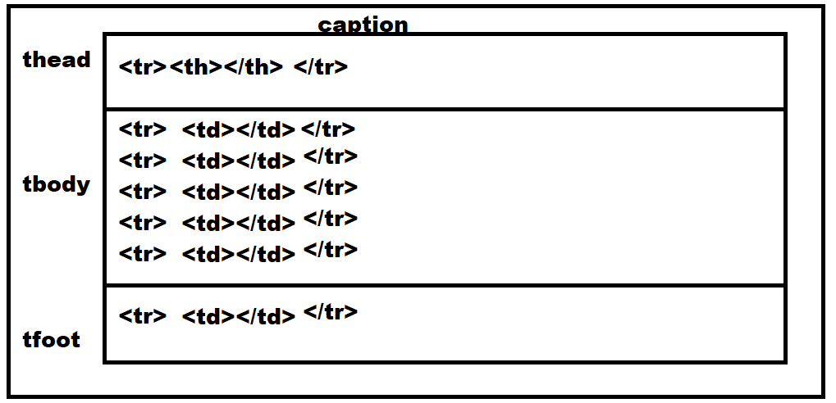

Attributes

- frame,rules,groups

frame : the frame represents table border.
The values of frame can be “box|lhs|rhs|above|below|none”

Syntax:
<table frame=“box|lhs|rhs|above|below|none”>

rules : the rules are given as rows or cols
The value of rules can be

Syntax:
<table rules=”rows|cols|all |groups|none”>

groups : this allows to group cols. This grouping can be applied by using span tag/element.

Note: to apply column group, the rules must be groups.

Syntax:
<table>
<colgroup span=”n columns”>
</table>

Example:
<!DOCTYPE html>
<html lang="en">
<head>
<meta charset="UTF-8">
<meta name="viewport" content="width=device-width, initial-scale=1.0">
<title>IPL</title>
</head>
<body>
<table width="100%" frame="box" rules="groups">
<caption>Test Ranking</caption>
<colgroup span="2"></colgroup>
<thead>
<tr>
<th>Pos</th>
<th>Team</th>
<th>Players</th>
<th>Rating</th>
<th>Career Best Rating</th>
</tr>
</thead>
<tbody>
<tr>
<td>01</td>
<td><img src="images/ind.JPG" >IND</td>
<td>Rohit Sharma</td>
<td>1000</td>
<td>923 v India at Edgbaston 2022</td>
</tr>

<tr>
<td>02</td>
<td><img src="images/eng.JPG" >ENG</td>
<td>Joe Root</td>
<td>872</td>
<td>923 v India at Edgbaston 2022</td>
</tr>
<tr>
<td>03</td>
<td><img src="images/nz.JPG" >NZ</td>
<td> Kane Williamson</td>
<td>859</td>
<td>919 v Pakistan at Christchurch 2021</td>
</tr>
<tr>
<td>04</td>
<td><img src="images/pak.JPG" >PAK</td>
<td> Babar Azam</td>
<td>768</td>
<td>882 v New Zealand at Karachi 2022</td>
</tr>
</tbody>
<tfoot>
<tr><th>ICC Test Ranking</th></tr>
</tfoot>
</table>
</body>
</html>

29/08/24
Attributes of table

border : This attribute is used to give table and cell border

Cell spacing and cell padding

cellspacing : this attribute is used to define the space between cells

cellpadding : Inside cell the space between content

These are table level attributes and used at table level.

Syntax:
<table width=”80%” border=”1” cellspacing=”20” cellpadding=”20”>

align,valign,width,height

width : This attribute is given at column level (cell). If this attribute is set one cell within column, automatically applied to all the cells within column

height : This attribute given at row level (tr).

Syntax:

<table width=”100%” border=”1”>
<thead>
<tr>
<th width=”100”>text </th>
<th width=”100”>text </th>
<th width=”100”>text </th>
</tr>
</thead>

align : This attribute is used to align text horizontally. The value of this attribute can be left | right | center | justify
valign: This attribute is used to align text vertically. The value of this attribute can be top|bottom|center

These attributes can be applied at row level(tr) and column level (td/th).
If it is applied at row level, this alignment is done for all the cells within row

Syntax:
<table width="100%" border="1" >
<caption>Test Ranking</caption>
<thead>
<tr height="80">
<th width="100" align="left" valign="top">Pos</th>
<th width="300" align="right">Team</th>
<th width="100">Players</th>
<th width="80">Rating</th>
<th width="400">Career Best Rating</th>
</tr>
</thead>

background,bgcolor

bgcolor: This attribute is used to apply the background color of table or row or cell
background: This attribute is used to apply the background image

Syntax:
<table bgcolor=”color”>
<tr bgcolor=”color”>
<td bgcolor=”color”>text</td>
</tr>
</table>

Syntax:

<table background=”image path”>
</table>

rowspan,colspan

These attributes are used to merge rows or columns

rowspan : This attribute is for merging rows
colspan: This attribute if for merging columns

Example
<!DOCTYPE html>
<html lang="en">
<head>
<meta charset="UTF-8">
<meta name="viewport" content="width=device-width, initial-scale=1.0">
<title>IPL</title>
</head>
<body>
<table width="100%" border="1">
<caption>Test Ranking</caption>

<thead>
<tr height="80">

<th width="100" >Pos</th>
<th width="300" >Team</th>
<th width="100">Players</th>
<th width="80">Rating</th>
<th width="400">Career Best Rating</th>

</tr>
</thead>
<tbody>
<tr height="100">
<td >01</td>
<td><img src="images/ind.JPG" >IND</td>
<td >Rohit Sharma</td>
<td>1000</td>
<td>923 v India at Edgbaston 2022</td>
</tr>

<tr >
<td>02</td>
<td><img src="images/eng.JPG" >ENG</td>
<td>Joe Root</td>
<td>872</td>
<td>923 v India at Edgbaston 2022</td>
</tr>
<tr >
<td>03</td>
<td><img src="images/nz.JPG" >NZ</td>
<td> Kane Williamson</td>
<td>859</td>
<td>919 v Pakistan at Christchurch 2021</td>
</tr>
<tr >
<td>04</td>
<td><img src="images/pak.JPG" >PAK</td>
<td> Babar Azam</td>
<td>768</td>
<td>882 v New Zealand at Karachi 2022</td>
</tr>
</tbody>
<tfoot>
<tr ><th colspan="5" align="right">ICC Test Ranking</th></tr>
</tfoot>
</table>
</body>
</html>

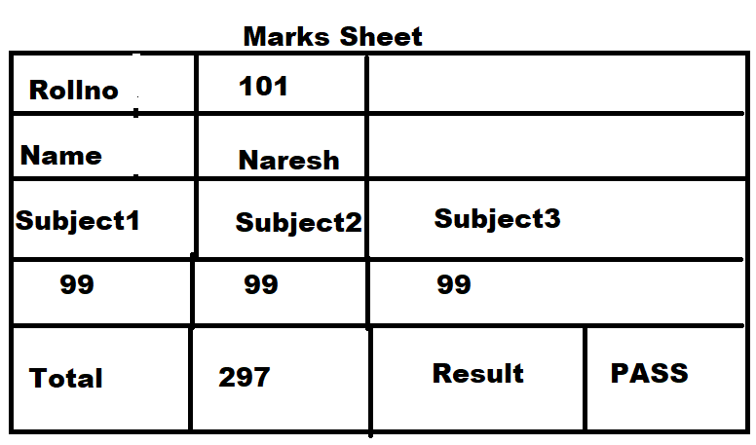

Example
<!DOCTYPE html>
<html lang="en">
<head>
<meta charset="UTF-8">
<meta name="viewport" content="width=device-width, initial-scale=1.0">
<title>Document</title>
<style>
table
{
font-size: 30px;
font-weight: bold;
}
</style>
</head>
<body>
<table border="1" width="100%">
<caption>Marks Sheet</caption>
<tr>
<td>Rollno</td>
<td colspan="3">101</td>
</tr>
<tr>
<td>Name</td>
<td colspan="3">Naresh</td>
</tr>
<tr>
<td>Subject1</td>
<td>Subject2</td>
<td colspan="2">Subject3</td>
</tr>
<tr>
<td>99</td>
<td>99</td>
<td colspan="2">99</td>
</tr>
<tr>
<td>Total</td>
<td>297</td>
<td>Result</td>
<td>Pass</td>
</tr>
</table>
</body>
</html>

30/08/24
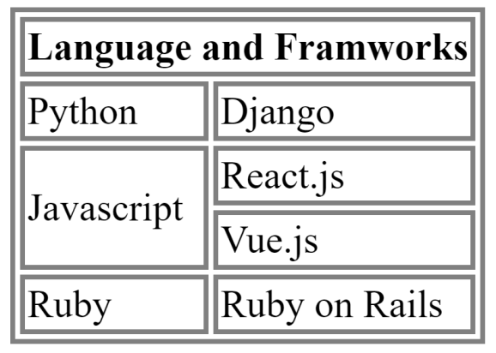

<!DOCTYPE html>
<html lang="en">
<head>
<meta charset="UTF-8">
<meta name="viewport" content="width=device-width, initial-scale=1.0">
<title>Courses Details</title>
<style>
table
{
font-size: 30px;
font-family: Arial;
}
</style>
</head>
<body>
<table border="5" width="80%">
<tr>
<th colspan="2">Language and FrameWorks</th>
</tr>
<tr>
<td>Python</td>
<td>Django</td>
</tr>
<tr>
<td rowspan="2">JavaScript</td>
<td>React.Js</td>
</tr>
<tr>
<td>Vue.Js</td>
</tr>
<tr>
<td>Ruby</td>
<td>Ruby on Rails</td>
</tr>
</table>

</body>
</html>

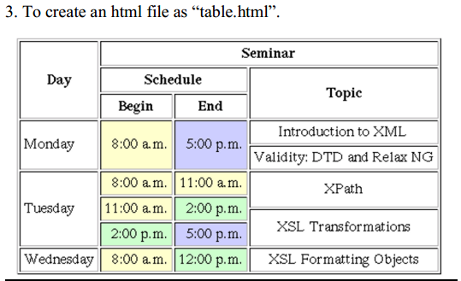

<!DOCTYPE html>
<html lang="en">
<head>
<meta charset="UTF-8">
<meta name="viewport" content="width=device-width, initial-scale=1.0">
<title>Courses Details</title>
<style>
table
{
font-size: 30px;
font-family: Arial;
}
</style>
</head>
<body>
<table border="5" width="100%" cellpadding="10">
<tr>
<th rowspan="3">Day</th>
<th colspan="3">Seminar</th>
</tr>
<tr>
<th colspan="2">Schedule</th>
<th rowspan="2">Topic</th>
</tr>
<tr>
<th>Begin</th>
<th>End</th>
</tr>
<tr>
<td rowspan="2">Monday</td>
<td rowspan="2">8:00 am</td>
<td rowspan="2">5:00 pm</td>
<td>Introduction to XML</td>
</tr>
<tr>
<td>Validity:DTD and RelaxNG</td>
</tr>
<tr>
<td rowspan="3">TuesDay</td>
<td>8:00am</td>
<td>11:00am</td>
<td rowspan="2">XPath</td>
</tr>
<tr>
<td>11:00am</td>
<td>2:00pm</td>
</tr>
<tr>
<td>2:00pm</td>
<td>5:00pm</td>
<td>XSL Tansformations</td>
</tr>
<tr>
<td>WednesDay</td>
<td>8:00am</td>
<td>12:00pm</td>
<td>XSL Formatting Objects</td>
</tr>
</table>

</body>
</html>

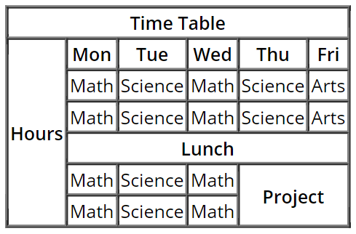

<!DOCTYPE html>
<html lang="en">
<head>
<meta charset="UTF-8">
<meta name="viewport" content="width=device-width, initial-scale=1.0">
<title>Courses Details</title>
<style>
table
{
font-size: 30px;
font-family: Arial;
}
</style>
</head>
<body>
<table border="2" width="80%">
<tr>
<th colspan="6">Time Table</th>
</tr>
<tr>
<th rowspan="6">Hours</th>
<th>Mon</th>
<th>Tue</th>
<th>Web</th>
<th>Thu</th>
<th>Fri</th>
</tr>
<tr>
<td>Maths</td>
<td>Science</td>
<td>Maths</td>
<td>Science</td>
<td>Arts</td>
</tr>
<tr>
<td>Maths</td>
<td>Science</td>
<td>Maths</td>
<td>Science</td>
<td>Arts</td>
</tr>
<tr>
<td colspan="5" align="center">Lunch</td>
</tr>

<tr>
<td>Maths</td>
<td>Science</td>
<td>Maths</td>
<td rowspan="2" colspan="2">Project</td>
</tr>
<tr>
<td>Maths</td>
<td>Science</td>
<td>Maths</td>
</tr>
</table>

</body>
</html>

HTML form elements
HTML is used for creating UI (User Interface) for web application.

What is form?
A form is container, where end user or client input data and submit this data to backend or another program.

This form is created using <form> element

Syntax:
<form action=”URL” method=”Request Method”>

</form>

What is URL, URI, URN?
URL stands for Uniform Resource Location
URI stands for Uniform resource Identification
URN stands for Uniform Resource Name

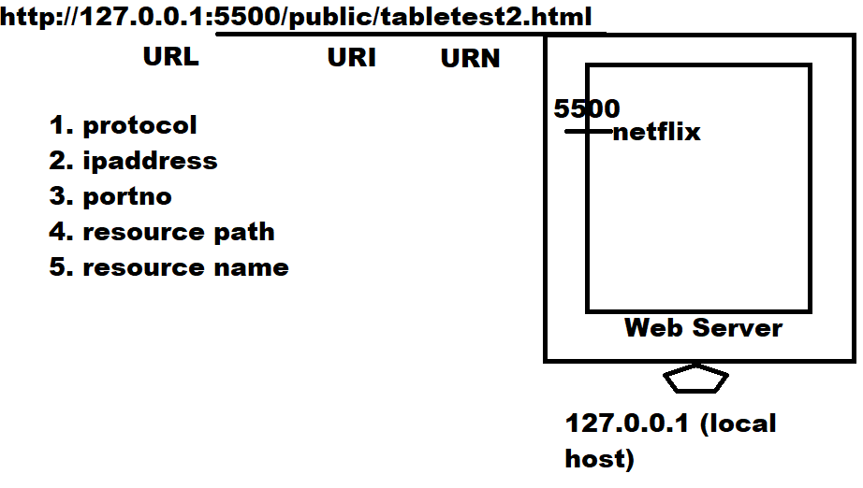

action
Action is event which is executed when end user click on submit button.
When end user click on submit button form data is submitted to resource given in action.

Method

31/08/24
action
Action is event which is executed when end user click on submit button.
When end user click on submit button form data is submitted to resource given in action.

method

Method defines HTTP request method.

What is request?
Input given by end user to the server is called request.

What is response?
The output given by server to the client is called response

In internet client/server communication is done using HTTP protocol.
HTTP stands for Hyper Text Transfer Protocol.

HTTP provides various request methods
- GET
- POST
- PUT
- DELETE
- PATCH

GET:
GET is request to read information from server but not writing information to server.
Example:
- Type URL in browser and press enter
- Query data or information

In request method GET, the data is concatenated with URL
The data is visible on URL bar.
Secured data cannot send using GET method.
Always data send as text format.
Using GET we cannot send large amount of data because URL length. This maximum length of URL is 2048 characters.
GET request is not secured,
- Visible on URL
- URL injection

POST
In request method POST, the data is send as part request body (OR) send as stream. It is not visible on Address/URL bar.
POST is request writing information to server.
Example:
Inserting data/registration

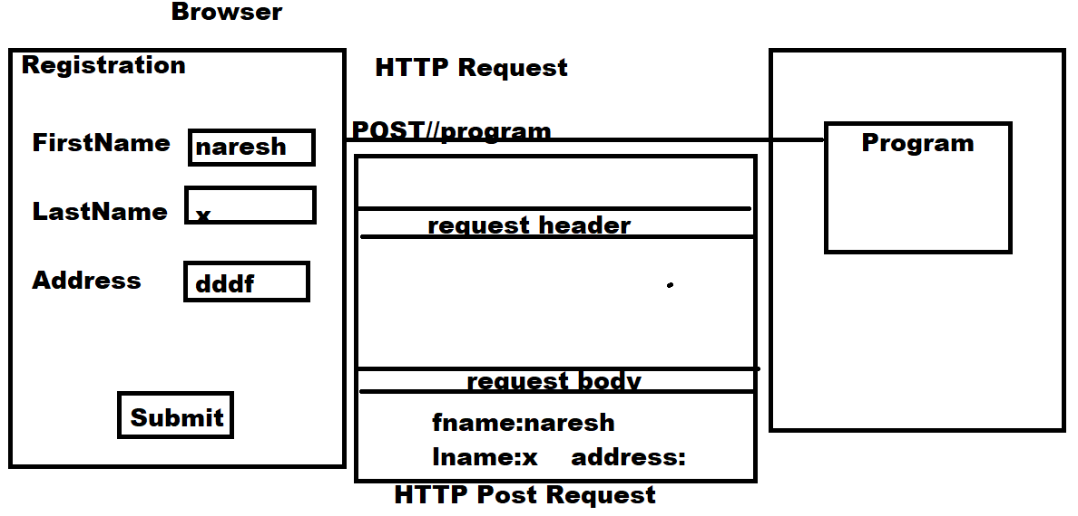

In post request,
- Any type of data can be send
- There is no restriction on sending of data
- There is no chance of URL injection

target

This attribute where display generated response.
The value of target can be,
_self
_blank

02/09/24
Form Elements or tags

Form is created or designed using form elements or tags
Form elements are used for creating UI (User interface).

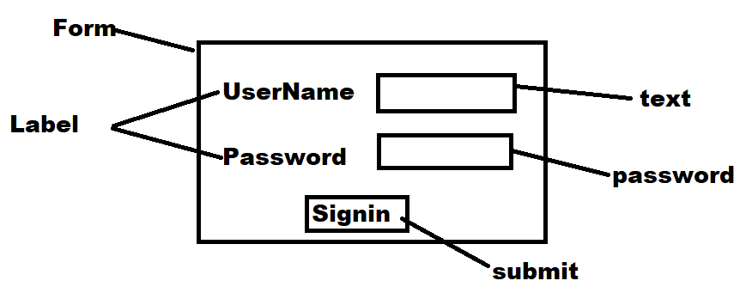

Label
Label is used for creating caption for input element
Label is used to identify input element (OR) data.

Syntax:
<label for=”name”>text</label>

Name is used to identify the label.
This name is used as an id for input element.
By clicking on label, the input element can focused using linking with id.

Input

HTML5 supports various types of input elements or types.

<input type=text name=”name” id=”id of label”>

It is used to input text.
Value inside input field is identified with name.

Submit, Reset, Button

HTML 5.0 provides 3 types of buttons

- Submit button

This button is having predefined functionality. When end user click on submit button the form data is submitted to given url. (OR) when end user clicks on submit button action is performed.

Syntax:
<input type=”submit” value=”text”>

Value is used to change display text, the default display text form input type submit is submit.

- Reset button

This button is having predefined functionality. When end user click on reset button the form data is cleared.

Syntax:
<input type=”reset” value=”text”>

- Button

Input button does not have any predefined functionality. This functionality must be defined by programmer using java script.

Syntax:
<input type=”button” value=”text” onclick=function>

Example:
<!DOCTYPE html>
<html lang="en">
<head>
<meta charset="UTF-8">
<meta name="viewport" content="width=device-width, initial-scale=1.0">
<title>Document</title>
<style>
fieldset
{
font-size: 20px;
font-weight: bold;
padding:50px;
}
label {
border: 1px solid black;
color:blue;
}
.s {
font-size: 20px;
font-family: Arial, Helvetica, sans-serif;
padding: 20px;
background-color: aqua;
color:red;
border-color: blueviolet;
border-radius: 15px;
width: 150px;

}
</style>
</head>
<body>
<form action="index.html">
<fieldset>
<legend>User Information</legend>
<label for="uname">UserName</label>
<input type="text" name="uname" id="uname"><br><br>
<label for="name">Name</label>
<input type="text" name="name" id="name"><br><br>
<input type="submit" value="Login" class="s">
<input type="reset" value="clear" class="s">
<input type="button" value="validate" class="s">
</fieldset>
</form>
</body>
</html>

<input type=”password”>

This input type used to input password values. The content input inside password field is not visible.

<!DOCTYPE html>
<html lang="en">
<head>
<meta charset="UTF-8">
<meta name="viewport" content="width=device-width, initial-scale=1.0">
<title>Login Form</title>
<style>
</style>
</head>
<body>
<form>
<table border="1" width="80%">
<caption>Login</caption>
<tr>
<td><label for="uname">UserName</label></td>
<td><input type="text" name="uname" id="uname" required></td>
</tr>
<tr>
<td><label for="pwd">Password</label></td>
<td><input type="password" name="pwd" id="pwd" required></td>
</tr>
<tr>
<td><input type="submit"></td>
<td><input type="reset"></td>
</tr>
</table>
</form>
</body>
</html>

Attribute
required : if this attribute is assigned to any input field, input is required before submitting form.

03/09/24
<input type=number>

This input field type allows to input only numbers

Syntax:
<input type=”number” name=”field-name”>

Attributes
- Min : This define minimum value
- Max : This define maximum value
- Value: This define default value
- Placeholder : text displayed within input field

<input type=hidden>
This is for creating hidden field, this field is not visible to end user.
End user cannot input value inside hidden field.

In web application development hidden fields are used for session management or tracking.

- Value : this define hidden field value

Inside hidden field value is given by server side program.

<input type=”email”>

<input> elements of type email are used to let the user enter and edit an email address

- multiple : This attribute allows input multiple email addresses by separating with , the value of this multiple can be True/False

Syntax:
<input type=”email” value=hr@nareshit.com placeholder=”Mail Address” multiple=”true/false”>

<input type=”tel”>
<input> elements of type tel are used to let the user enter and edit a telephone number.

Syntax:
<input type=”tel”>

If telephone number pattern is not defined it allows any pattern.
This pattern is defined using regex (regular expression)

Example:
<!DOCTYPE html>
<html lang="en">
<head>
<meta charset="UTF-8">
<meta name="viewport" content="width=device-width, initial-scale=1.0">
<script>

</script>
<style>
</style>
</head>
<body>
<form>
<label for="age">Age</label>
<input type="number" name="personage" id="age" min="1" max="200" value="10" ><br><br>
<label for="name">Name</label>
<input type="text" name="pname" id="name" placeholder="Person Name"><br>
<input type="hidden" name="uname" value="nit"><br>
<label for="email">Email</label>
<input type="email" name="email" id="email" multiple="true" placeholder="Email Address"><br>
<label for="phno">Telephone No</label>
<input type="tel" name="phno" id="phno" pattern="[0-9]{10}">

<input type="submit">
</form>
</body>
</html>

04/09/24
<input type=date>

This input field display date or input date. This input field display date picker.

Attributes

- Value
- Min
- Max

Syntax:
<input type=date value=”2024-03-12” min=”2020-01-01” max=”2025-01-01”>

Example:
<form>
<input type="date" value="2020-03-01" max="2025-01-01" min="2000-01-01">
<input type="submit">
</form>

<input type=time>
Input type=time allows input time or it display time picker

Syntax:
<input type=time>

<input type=datetime>
This input type is available in HTML 4.0 and this deleted from HTML 5.0
This input type allows to input date and time

Syntax:
<input type=”datetime”>

<input type=”radio”>

<input type=”radio”> used for displaying radio buttons.
Radio buttons used to display set of options or list values. In given list of values end user select only one value.

<input type=”radio” name=”name” value=”value”>

Example
<!DOCTYPE html>
<html lang="en">
<head>
<meta charset="UTF-8">
<meta name="viewport" content="width=device-width, initial-scale=1.0">
</head>
<body>
<form>
<label for="courses">Courses</label><br>
<input type="radio" name="course" value="java">Java <br>
<input type="radio" name="course" value="oracle">Oracle<br>
<input type="radio" name="course" value="python">Python <br>
<input type="radio" name="course" value=".net">.Net<br>

<lable for="fs">Full Stack</lable><br>
<input type="radio" name="fsc" value="fsj">Full Stack Java<br>
<input type="radio" name="fsc" value="fsn">Full Stack .Net<br>
<input type="radio" name="fsc" value="fsp">Full Stack Python<br>

<br>
<label for="q1">HTML is</label><br>
<input type="radio" name="q1" value="language">Language<br>
<input type="radio" name="q1" value="markup">Markup Language<br>
<input type="radio" name="q1" value="script">Scripting Language <br>

<input type="submit">
</form>
</body>
</html>

<input type=checkbox>
Input type=checkbox allows to display list of values or options.
In a given list of values or options end used select one or more than one value.

Syntax:
<input type=”checkbox” name=”name” value=”value” checked=”true/false”>

Note: grouping of radio buttons and checkbox are done by giving same name.

<!DOCTYPE html>
<html lang="en">
<head>
<meta charset="UTF-8">
<meta name="viewport" content="width=device-width, initial-scale=1.0">
</head>
<body>
<form>
<label for="products">Electronics</label><br>
<input type="checkbox" name="p" value="keyborad">Keyboard <br>
<input type="checkbox" name="p" value="monitor">Monitor <br>
<input type="checkbox" name="p" value="mouse">Mouse <br>
<label for="books">Books</label><br>
<input type="checkbox" name="b" value="java">Java<br>
<input type="checkbox" name="b" value="python">Python<br>

<input type="submit">
</form>
</body>
</html>

<select>

This tag or element is used to create scrollable list of values (OR) dropdown or (OR) Menu

Syntax:
<select name=”name”>
<option value=”value”>Display Value</option>
<option value=”value”>Display Value</option>
<option value=”value”>Display Value</option>
</select>

Attribute
multiple: This value can be true/false. This attribute allows to select one or more than one value.

Example:
<!DOCTYPE html>
<html lang="en">
<head>
<meta charset="UTF-8">
<meta name="viewport" content="width=device-width, initial-scale=1.0">
</head>
<body>
<form>
<select name="course1">
<option>Java</option>
<option>Oracle</option>
<option>.Net</option>
<option>Python</option>
<option>UI</option>
</select><br><br><br><br><br><br>
<select name="course2" multiple="true">
<option>Java</option>
<option>Oracle</option>
<option>.Net</option>
<option>Python</option>
<option>UI</option>
</select><br>
<br><br><br>
<input type="submit">
</form>
</body>
</html>

<optgroup>
This allows to group the options by separating with line. This line defined using <hr>.

Attribute

<optgroup label=”group label”>

Syntax:
<select name=”name” multiple=”true/false”>
<optgroup label=”grouplabel”>
<option value=”value”>Value</option>
<option vaue=”value”>Value</option>
<option value=”value”>Value</option>
</optgroup>
<hr>
<optgroup label=”grouplabel”>
<option value=”value”>Value</option>
<option vaue=”value”>Value</option>
<option value=”value”>Value</option>
</optgroup>
</select>

Example:
<!DOCTYPE html>
<html lang="en">
<head>
<meta charset="UTF-8">
<meta name="viewport" content="width=device-width, initial-scale=1.0">
</head>
<body>
<form>
<select name="course" multiple="true">
<option value="none">----select option---</option>
<optgroup label="Language">
<option value="java">Java</option>
<option value="pyhon">Python</option>
<option value=".net">.Net</option>
</optgroup>
<hr>
<optgroup label="Database">
<option value="oracle">Oracle</option>
<option value="mysql">MySQL</option>
<option value="mongodb">MongoDB</option>
</optgroup>
</select>
<input type="submit">
</form>
</body>
</html>

<input type=file>

<input type=file> allows to input file or display file picker.

Syntax:

<input type=file name=”name”>

<!DOCTYPE html>
<html lang="en">
<head>
<meta charset="UTF-8">
<meta name="viewport" content="width=device-width, initial-scale=1.0">
</head>
<body>
<form>
<input type="file">
<input type="submit">
</form>
</body>
</html>
<input type=”url”>

This input type is used to input URL

<!DOCTYPE html>
<html lang="en">
<head>
<meta charset="UTF-8">
<meta name="viewport" content="width=device-width, initial-scale=1.0">
</head>
<body>
<form>
<input type="url">
<input type="submit">
</form>
</body>
</html>

The end

